Grade: | Kindergarten |  |  |  |  | Grade 1 |  |  |  |  |  |  | Grade 2 |  |  |  |  |  |  | Grade 3 |  |  |  |  | Grade 4 |  |  |  |  |  | Grade 5 |  |  |  |  |  | Grade 6 |  |  |  | Grade 7 |  |  | Grade 8 |  | Grade 9
Whole Number Outcomes | NK.5  -comparing  NK.4  -partitioning numbers 1 to 10 |  |  |  |  | N1.5  -comparing sets  N1.7  -equal groupings with and without singles |  |  |  |  |  |  | N2.1  -comparing numbers 1 to 100  (using patterning) |  |  |  |  |  |  | N3.1  -comparing numbers 1 to 1000 |  |  |  |  |  |  |  |  |  |  |  |  |  |  |  |  |  |  |  |  |  |  |  |  |  | N9.2  -understanding rational numbers
Fraction Outcomes |  |  |  |  |  |  |  |  |  |  |  |  |  |  |  |  |  |  |  | N3.4  -understanding fractions |  |  |  |  | N4.6  -understanding fractions less than or equal to one (order, compare |  |  |  |  |  | N5.5  -equivalent fractions, comparing, ordering |  |  |  |  |  | N6.7  -improper fractions and mixed numbers
Operations with Fractions Outcomes |  |  |  |  |  |  |  |  |  |  |  |  |  |  |  |  |  |  |  |  |  |  |  |  |  |  |  |  |  |  | N5.7  -adding and subtracting decimals |  |  |  |  |  | N6.4  -multiply and divide decimal numbers |  |  |  | N7.5  -addition and subtraction of fractions and mixed numbers with like and unlike denominators |  |  | N8.4  -multiplying and dividing positive fractions and mixed numbers
Related Representation Outcomes |  |  |  |  |  |  |  |  |  |  |  |  |  |  |  |  |  |  |  |  |  |  |  |  | N4.7  -decimal numbers (tenths and hundredths)  N4.8  -addition and subtraction of decimal numbers to hundredths |  |  |  |  |  | N5.6  -decimal numbers to thousandths  N5.7  -addition and subtraction of decimal numbers to thousandths |  |  |  |  |  | N6.1  - decimal numbers less than one thousandth  N6.5  -percent  N6.8  -ratio |  |  |  | N7.2  -addition and subtraction of decimals and order of operations  N7.3  -relationship between decimals, fractions and whole numbers  N7.4  -fractional percent |  |  | N8.2  -percent greater than or equal to 0  N8.3  -ratios, rates and proportions
Progression of Learning | Kindergarten |  |  | Grade 1 |  |  |  |  | Grade 2 |  |  |  |  | Grade 3 |  |  | Grade 4 |  |  |  |  | Grade 5 |  |  |  | Grade 6 |  | Grade 7 |  |  |  | Grade 8 |  |  | Grade 9
 | Student can partition into parts or sets.
 |  |  |  | Student can partition objects and sets into equal parts.
Student recognizes fractions represented by pictures and objects
Student understands fractions as counting all parts (denominator) and shaded part or non-shaded parts (numerator)
Student understands fractions as partitioning a whole into equal parts and selecting parts.
Students can compare fractions concretely and visually
Students are introduced to the symbolic representations of fractions
Student understands fractions as partitioning a set into equal parts and selecting some.
Students compare fractions to the benchmarks 0, ½, and 1
Students understand that the size of a fraction is related to the whole (eg. ½ of a large pizza is more than ½ of a small pizza)
Students relate decimal numbers in tenths and hundredths to fractions.
Students relate decimal numbers in thousandths to fractions.
Students can concretely, pictorially, symbolically, and use mental math strategies of decimal numbers to solve addition and subtraction problems.
Students can represent and generate equivalent fractions.
Students can concretely, pictorially, symbolically, and use mental math strategies of decimal numbers to solve multiplication and division problems.
Students develop an understanding of mixed and improper fractions by creating concrete and pictorial models.
Students can convert between mixed and improper fractions symbolically.
Students understand the difference between a fraction and a ratio.
Students can concretely, pictorially, and symbolically represent addition and subtraction of fractions.
Students understand the use of common denominators when adding and subtracting fractions symbolically.
Students can convert among fractions, decimals and percent.
Students can do order of operations with decimal numbers.
Students can solve problems using percentages.
Students understand that a/b could be a fraction, operation, rate, or ratio.
Students can multiply and divide fractions and mixed numbers.
Students extend understanding of percent greater than 100 and between 0 and 1.
Students can use order of operations with all types of numbers.
Students define and use rational numbers.
Big Ideas | Kindergarten |  |  | Grade 1 |  |  |  |  | Grade 2 |  |  |  |  |  | Grade 3 |  |  | Grade 4 |  |  |  |  | Grade 5 |  |  |  | Grade 6 |  | Grade 7 |  |  |  | Grade 8 |  |  |  |  | Grade 9
 | We can partition objects and collections into two or more equal-sized parts and the partitioning can be done in different ways. (FSiM KU2)
 |  |  |  | We can partition into equal and unequal groups.
We use fraction words and symbols to describe parts of a whole. The whole can be an object, a collection or a quantity. (FSiM KU3)
The fraction is in relation to the whole. The whole can be represented by a set or region. You have to know what the whole is to say what the parts represent.
If the numerator and denominator of a fraction are equal, the fraction represents one whole or 1.
The same fractional quantity can be represented with a lot of different fractions. We say fractions are equivalent when they represent the same number or quantity. (FSiM KU4)
We can compare and order fractional numbers and place them on a number line. (FSiM KU5)
Operations with fractions have the same meaning as operations with whole numbers.
Fractions can represent ratios.
A fraction symbol may show a relationship between two quantities. Percentages are a special kind of ratio we use to make comparisons easier. (FSiM KU7)
There are multiple models and/or procedures for computing with fractions, just as with whole numbers.
Fractions with numerators greater than the denominator, are greater than 1.
 |  |  |  |  |  |  |  |  |  |  |  |  |  |  |  |  |  |  |  |  |  |  |  |  |  |  |  |  | A fractional number can be written as a division or as a terminating or repeating decimal. (FSiM KU6)
Vocabulary | Kindergarten |  |  |  |  | Grade 1 |  |  |  |  |  |  | Grade 2 |  |  |  |  |  |  | Grade 3 |  |  |  |  | Grade 4 |  |  |  |  |  | Grade 5 |  |  |  |  |  | Grade 6 |  |  |  |  | Grade 7 |  | Grade 8 |  | Grade 9
 | More than  Less than  Same as |  |  |  |  | Equal  Fewer |  |  |  |  |  |  | Greater than |  |  |  |  |  |  | Fraction  Numerator  Denominator  Compare  Whole  Half  Third  Quarter  Unit fractions (has a numerator of 1) |  |  |  |  | Tenths  Hundredths  Decimal  Proper fraction (the numerator is less than the denominator)  Equivalent decimal numbers  Benchmark |  |  |  |  |  | Equivalent fractions  Thousandths  Simplify (reduce to lowest terms) |  |  |  |  |  | Improper fraction (the numerator is greater than the denominator and therefor the fraction is greater than one whole)  Percent  Ratio (comparison between two different things)  Mixed numbers (includes a fraction and whole number) |  |  |  |  | Common denominator  repeating decimal  terminating decimal Order of operations |  | Rate (a quantity measured with respect to another measured quantity)  Reciprocal (opposite or inversely related) |  | Rational number (a number that can be written as a simple fraction)  Irrational number (a number that can be expressed as an infinite decimal with no set of consecutive digits repeating itself indefinitely and that cannot be expressed as the quotient of two integers)
Instructional Strategies | Kindergarten |  |  |  |  |  |  |  |  |  |  |  |  |  |  |  |  |  |  |  | Grade 1 |  |  |  |  |  |  |  |  |  |  |  |  |  |  |  |  |  | Grade 2
Use number lines to find whole numbers and compare whole numbers.
Use objects to count, compare, partition, make equal groupings.
 | Grade 3 |  |  |  |  |  |  |  |  |  |  |  |  |  |  |  |  |  |  |  | Grade 4 |  |  |  |  |  |  |  |  |  |  |  |  |  |  |  |  |  | Grade 5
Concretely:
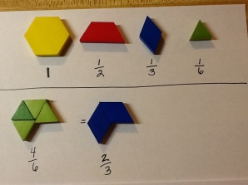
Use pattern blocks - use money - 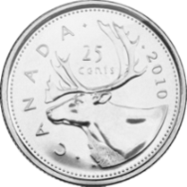 (a quarter is ¼ of a dollar) 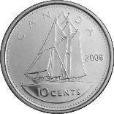 (a dime is 1/10 of a dollar)

Cuisinaire rods (each color determines the whole)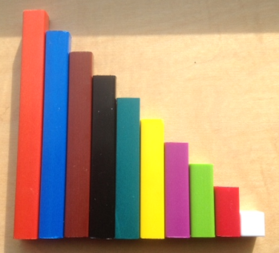 Fraction Stax - 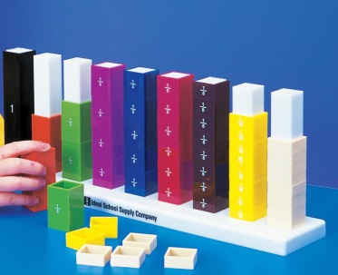 Fraction circles - 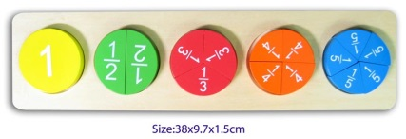

2-sided counters - 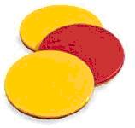 fraction strips - 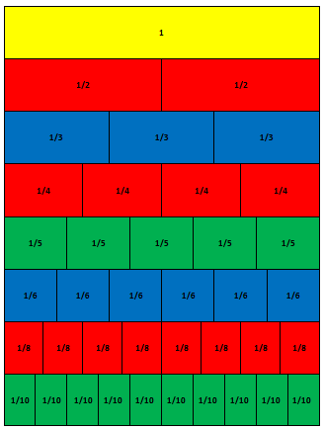 number lines with/without benchmarks - 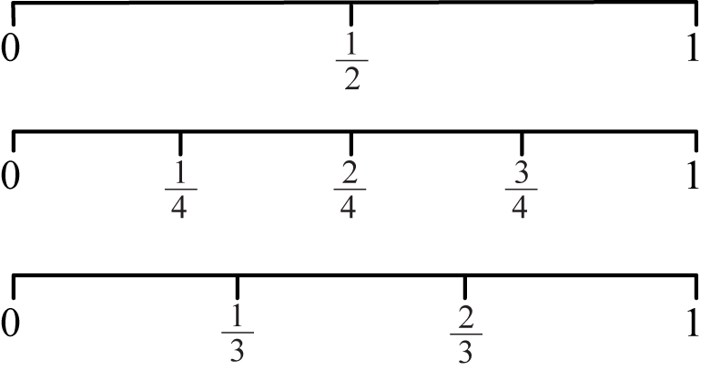

Pictorially:
Grid paper - 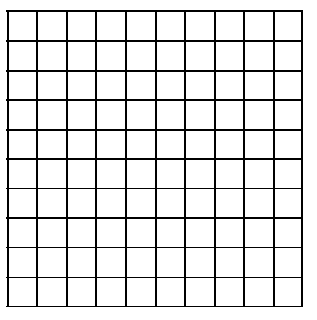 draw a picture - folded paper into equal parts, color the numerator
Provide students with different configurations of fractions. (grades 3, 4, 5)
Provide opportunities for students to estimate fractions by coloring a fraction of a whole and asking students to estimate the fraction. (Grades 3, 4, 5)
Use a hundreds chart cut in strips to manipulate and determine equivalent fractions. (Grade 5)
 | Grade 6 |  | Grade 7 |  |  |  |  | Grade 8 |  |  | Grade 9
 | Concrete manipulatives: fraction stax with improper fractions and mixed numbers (Grade 6)
 |  |  | Concrete manipulatives: fraction stax for adding and subtracting fractions (Grade 7)
 |  |  |  |  |  |  |  | Concrete manipulatives: fraction stax for multiplying and dividing fractions (Grade 8)
 | Virtual manipulatives
Common Misconceptions | Kindergarten |  |  | Grade 1 |  |  |  |  | Grade 2 |  |  |  |  | Grade 3 |  |  | Grade 4
 |  |  |  |  |  |  |  |  | Students see fractions as pieces of a whole but not equal pieces.
Students refer to ½ as one two-th.
Students will choose a quarter as larger than a third using understanding of whole numbers.
Students conceptualize common representations of fractions and will struggle recognize unfamiliar representations.
Students don’t recognize parts of a set as a fraction, only as parts of a whole.
Students don’t see that a fraction can be part of a set when the parts of the set are different. ¼ are stars.
Students don’t look at the complete set when determining the denominator.
Students identify identical fractions as identical quantity regardless of the size of the whole (ie: half of an class is viewed as the same amount as half of a school).

Students read decimal numbers using the word ‘point’. eg 6.2 is read six point two rather than six and two tenths.
Students align the digits rather than the decimals when adding and subtracting decimals.

 | Grade 5 | Grade 6 |  |  |  |  | Grade 7 |  |  | Grade 8 |  |  |  |  |  | Grade 9
Students have difficulty performing operations with fractions in meaningful correct ways because they lose track of the whole.
Students apply understanding of adding whole numbers to adding the numerators and denominators as separate whole numbers.
Students perceive two digit decimals as larger than single digit decimals eg. 0.18 is larger than 0.2.
 |  | Students struggle to conceive of a fraction being more than a whole and therefore struggle with improper fractions.
 |  |  |  |  |  |  | Students only see fractions as a number not also as an operation, rate or ratio.
Students view 0.5% the same as ½.
Students believe that 100% is the largest percent you can have.
Students believe that multiplication always results in a larger number and division results in a smaller number.
Students struggle to believe that dividing by 2 is the same as multiplying by ½.
 |  |  |  |  |  |  |  |  |  |  |  |  |  |  |  | Students believe that they have never worked with rational numbers before.
Assessment | Kindergarten |  |  |  | Grade 1 |  |  |  |  |  |  | Grade 2 |  |  |  |  |  |  | Grade 3 |  |  |  |  | Grade 4 |  |  |  |  |  | Grade 5 |  |  |  |  |  | Grade 6 |  |  |  | Grade 7 |  |  | Grade 8 |  | Grade 9
Pre-Assessment
Post-Assessment

