Show What you Know about Math! Name_KEY________________
How do you feel about Math? Circle one

- How many cats?
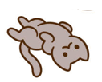
11
2) What number is shown here?  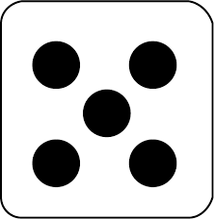  5 | 3) How many?  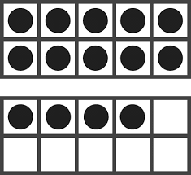  14
4) Draw 12 circles  Any arrangement of 12 shapes/dots/circles | 5) Draw dots to represent the number 24 in these ten frames  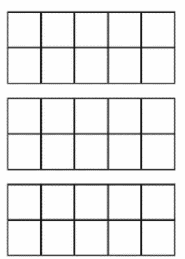  Any arrangement of 24
6) How many?  26 | 7) Write the number 13 in word form  Thirteen accept any reasonable spelling but make a note to work on that
8) Write these numbers in the blanks from lowest to highest

15 80 52 65 58

_____ _____ _____ _____ _____
9) Circle the set that has more candies
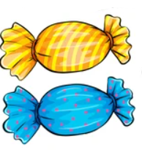
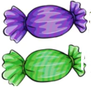
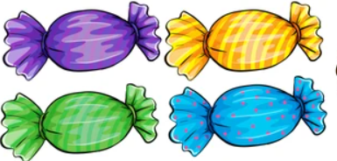

10) What number is 2 more than 11?
13
11) Circle the set that has fewer than 5.

12) What number is the double of 8?  16 | 13) Circle the odd numbers  12 9 55 72 80 31
14) There are 12 cookies. Share them equally by drawing cookies on the plates.
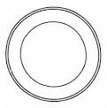

15) There are 16 beads in the bag, and 4 more outside the bag. How many beads all together?
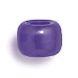
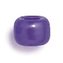
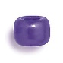
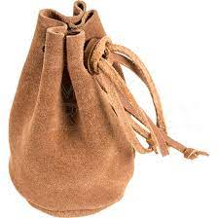
20
16) Queenie had 6 puppies. I see 2 puppies. How many more puppies are under the blanket?
4
17) Each caterpillar has 10 spots. How many spots altogether on 4 caterpillars?
40
18) Fill in the blanks

2, 4, 6, ____, _____, _____

19) Fill in the blank

80, 70, 60, ______, ______, ______
20) John’s Aunt buys bolts. There are 10 bolts in each package, and 6 more that aren’t in a package. How many bolts are there?
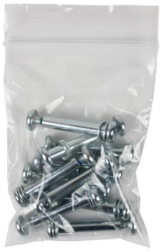
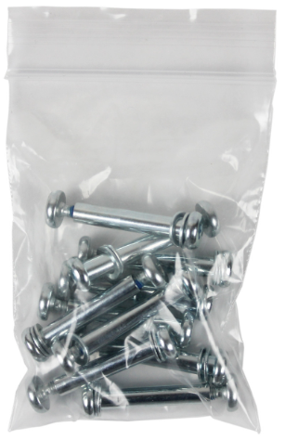

46
21)  8 + 2 = 10 | 22)  15 – 4 = 11
23)  52 + 13 =65 | 24)  14 + 0 = 14
25)  48 + 26 = 74 | 26)  58 – 25 =33
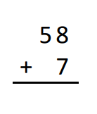  27) | 28)  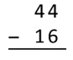
29)  32 – 14 = 18 | 30)  6 + 8 = 9 +
31) Draw blocks on the scale to make it balance
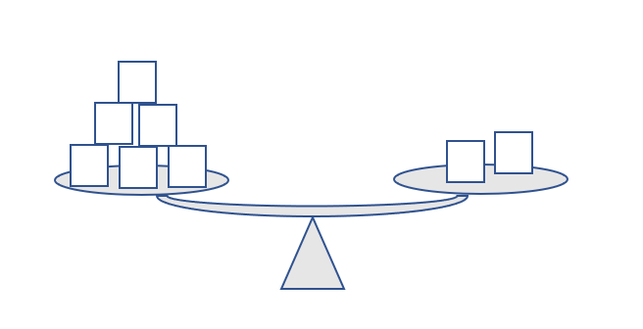

32) Continue the pattern

33) Draw the next figure in the pattern

34) Underline the cracker shaped like a triangle
