Christ the Teacher Grade 3 Screener Teacher Copy

- How many cats?
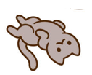
N1.3 Counting
2) What number is shown here?  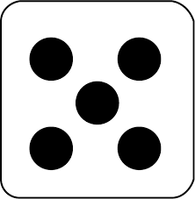 | 3) How many?  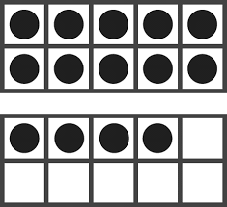
N 1.2 Subitize | N 1.3 Counting
4) Draw 12 circles | 5) Draw dots to represent the number 24 in these ten frames  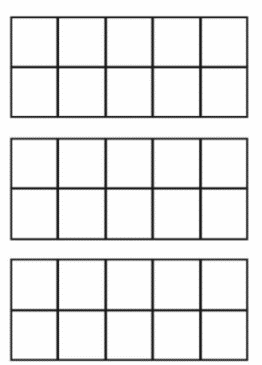
N 1.4 Representing whole numbers to 20 | N 2.1 Representing whole numbers to 100
6) How many? | 7) Write the number 13 in word form
N 2.1 N 1.4 Representing whole numbers to 100 | N 2.1 Represent
8) Write these numbers in the blanks from lowest to highest

15 80 52 65 58

_____ _____ _____ _____ _____
N 2.1 Ordering
9) Circle the set that has more candies
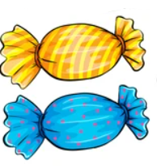
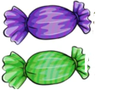
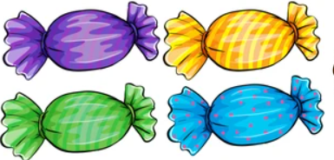
N 1.5 Comparing

10) What number is 2 more than 11?
N 1.8 Comparing, identifying
11) Circle the set that has fewer than 5.

N 1.5 Comparing
12) What number is the double of 8? | 13) Circle the odd numbers  12 9 55 72 80 31
N 2.2 Strategies Doubles | N 2.1 Odds and evens
14) There are 12 cookies. Share them equally by drawing cookies on the plates.
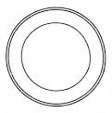

N 1.7 Equal groups

15) There are 16 beads in the bag, and 4 more outside the bag. How many beads all together?
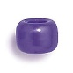
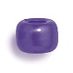
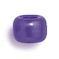
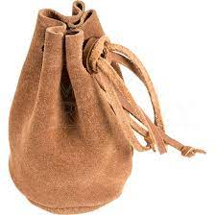
N 1.9 Addition
16) Queenie had 6 puppies. I see 2 puppies. How many more puppies are under the blanket?
N 1.9 Addition/subtraction
17) Each caterpillar has 10 spots. How many spots altogether on 4 caterpillars?
N2.1 Skip count
18) Fill in the blanks

2, 4, 6, ____, _____, _____

N1.1 Number sequence
19) Fill in the blank

80, 70, 60, ______, ______, ______
N2.1 Skip Count (backwards)
20) John’s Aunt buys bolts. There are 10 bolts in each package, and 6 more that aren’t in a package. How many bolts are there?
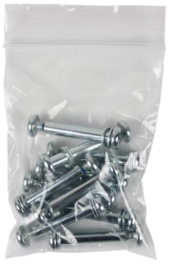
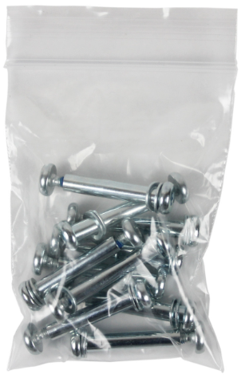

N2.2 Addition up to 100
21)  8 + 2 = | 22)  15 – 4 =
N 1.9 Addition within 20 | N 1.9 Subtraction within 20
23)  52 + 13 = | 24)  14 + 0 =
N 2.2 Addition within 100 (no regrouping) | N 2.2 Adding zero
25)  48 + 26 = | 26)  58 – 25 =
N 2.2 Addition within 100 (with regrouping) | N 2.2 Subtraction (no regrouping)
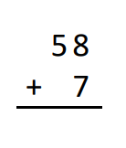  27) | 28)  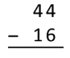
N 2.2 Addition (with regrouping)(stacked) | N 2.2 Subtraction (with regrouping)(stacked)
29)  32 – 14 = | 30)  6 + 8 = 9 +
N 2.2 Subtraction (with regrouping) | N 2.3 Equality
31) Draw blocks on the scale to make it balance
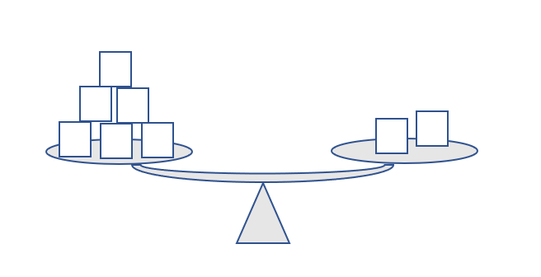

P 1.3 Equality
32) Continue the pattern

P1.1, P 2.1 Patterns
33) Draw the next figure in the pattern

P 2.1 Patterns
34) Underline the cracker shaped like a triangle
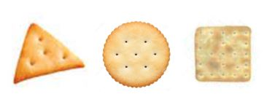

SS 2.4 2D Shapes

