Christ the Teacher Grade 4 Screener D1

How do you feel about Math? Circle one

Recall: We can represent a number several ways
Standard Form | Expanded form | Word form
6 458 | 6000 + 400 + 50 + 8 | six thousand four hundred fifty-eight

1) Write the number 14 in word form .
N2.1 Representing Number
2) Write $700 + 60+2$  in standard form. | 3) Write the number nine hundred thirty-seven in standard form.
N3.1 Representing Number | N3.1 Representing Number
4) How many? | 5) How much is 2 more than 10?
N 2.1 Representing Number | N2.2 Adding
6) What whole number is represented here?  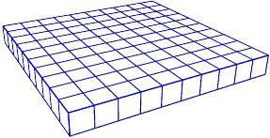  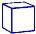 | 7) Write the value of the underlined digit.  526
N 3.1 Representing Number | N3.1 Place value
8) Draw 9 cookies, some on each plate, any way you like.
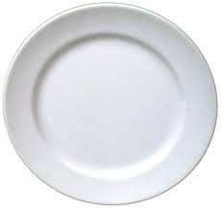

N 2.1 Representing Number, decomposing
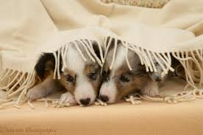  9) Mitsy has 8 puppies. I see 2 puppies. How many more puppies are under the blanket? | 10)  What number is the double of 6?
N 2.2 Addition | N 2.2 Addition
11) Add

₌
+
N 2.2 Addition
12) Fill in the boxes of this piece of the hundreds chart.
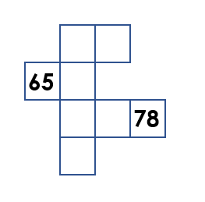

N3.1 Missing Values in Hundreds Chart
13) Order these numbers from least to greatest.
104
738
279
751

___________ ___________ ___________ ___________
N 3.1 Place Value
14) Fill in the blanks (Continue the pattern).

754, 764, 774, 784, _______ , _______ , ________

N3.1 Place Value
15) How much money?  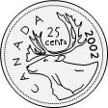  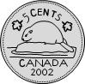  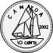  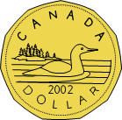 | 16) Add.  $58 + 0 =$
N3.1 Whole numbers (money) | N 3.2 Addition with zero
17) Skip count by 3.

__3__ _____ _____ _____ _____ _____
N3.1 Whole numbers
18) Skip count by 10 starting at 22.

__22_ _____ _____ _____ _____ _____
N3.1 Whole numbers
19) Add.  $41+17 =$ | 20) Subtract.  $$58-22 =$$
N2.2 Add | N 2.2 Subtract
21) Estimate the sum of the following.  Show your strategy.  $795 + 112$ | 22) Add.  $$341+201 =$$
N3.2 Estimation | N3.2 Add (no regrouping)
23) Add.  452  + 381 | 24) Subtract.  381  - 163
N3.2 Add (regrouping) | N3.2 Subtract (No regrouping)
25) Subtract.  $634 - 581 =$ | 26) Rewrite$6+6+6+6$ as a multiplication sentence.  _____ X _____ = _____
N3. Subtract (Regrouping) | N 3.3 Multiplication as repeated addition
27) $5 × 3 = 15$  Write the related division sentence.  ______ ÷_____ = _____ | 28) Multiply.  $$3 × 4 =$$
N 3.3 Relating multiplication and division | N3.3 Multiplication
29) Multiply.  $3 × 6=$ | 30) Divide.  $50 ÷ 5=$
N3.3 Multiplication facts | N3.3 Division facts
31) Divide.  $$21 ÷ 3 =$$ | 32) What multiplication sentence could this array represent?  _____ X _____ = _____
N3.3 Division | N 3.3 Representing Multiplication, array
33) What division sentence does this array represent?  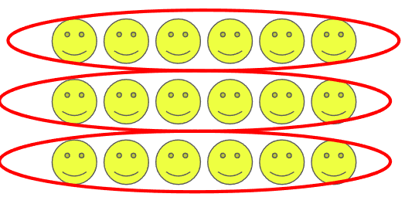  ____ ÷ ____ = _____ | 34) Estimate.  $$785- 114$$
N3.3 Representing Division, array | N3.2 Estimate sums
35) Name the fraction. | 36) There are 16 triangles. Circle $\frac{7}{16}$.
N 3.4 Representing fraction | N3.4 Fraction
37) There are 20 crayons to be shared equally by 5 students. How many crayons can each student get?
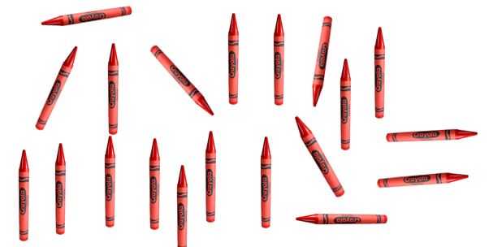
N 3.3 Division with remainder using model
38) Shade three-fifths of this chocolate bar.  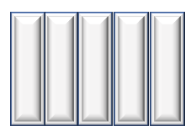 | 39)  3  8  Draw a picture to show .
N 3.4 Fraction | N 4.6 Fraction
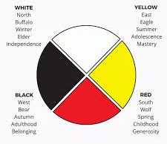  40) What fraction of this medicine wheel is white? | 41) Insert either < , >, or = between these two fractions.  3  9  7  9
N3.4 Fraction | N3.4 Fraction, compare
42) Circle the larger fraction.  $\frac{3}{4}$ $\frac{3}{10}$ | 43) What fraction of these items is ball gloves?  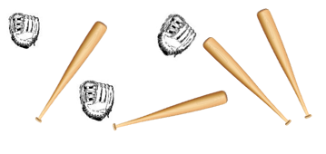
N3.4 Fraction, compare | N 3.4 Fraction of a set
44) Extend the pattern

________ ________ ________ ________
P2.1 Patterns
45)
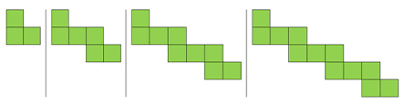
How many blocks are in the next figure?
P3.1 Patterns
46) What number does the circle represent?  $-6$ = 11 | 47) What number does the triangle represent?  6 + = 14
P3.2 Equations | P3.2 Equations
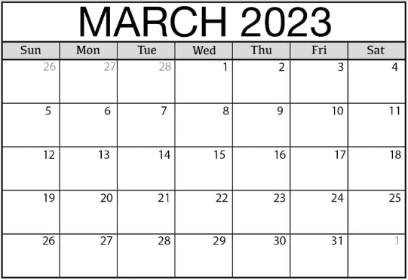
48) What day of the week is March 9?

SS 3.1 Time
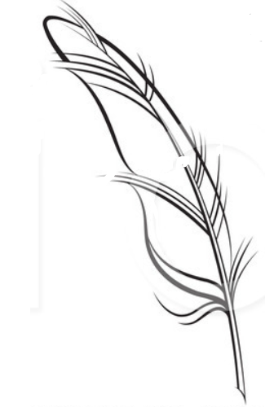
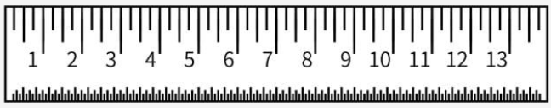
49) How long is this goose feather?

cm
SS2.1, SS3.2 Measuring

