Christ the Teacher Grade 5 Screener E1 Name Key

How do you feel about Math? Circle one

Recall: We can represent a number several ways
Standard Form | Expanded form | Word form
6 458 | 6000 + 400 + 50 + 8 | six thousand four hundred fifty-eight

1) Write 6 902 in word form. Six thousand nine hundred two
N4.1 Representing Number
2) Write 700 + 60 + 2  in standard form. 762 | 3) Write the number nine hundred thirty-seven in standard form.  937
N3.1 Representing Number | N3.1 Representing Number
4) Write the number nine thousand twenty-eight in standard form.  9 028 (if students don’t leave a space, its still correct) | 5) Write the value of the underlined digit.  526 Five hundred or 5 hundred  If a student writes “500” ask them to say the number and/or write it out in words
N4.1 Representing Number | N3.1 Place value
6) Write the value of the underlined  digit.  4 904  Four thousand or 4 thousand | 7) Write a number greater than 3 450 and less  than 4 000.  Anything from 3 451 – 3 999
N4.1 Place value | N4.1 Place value
8) Write the number 9 067 in expanded form.
9000 + 60 + 7 (if a student includes 000 for the hundreds place, have a conversation but you can score the item correct)
N3.1 N4.1 Representing Number
9) Fill in the blanks to continue the counting pattern:

997 , 998 , 999, 1000, 1001

N 4.1 Representing Number, Place Value
10) What whole number is represented here? 364
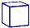
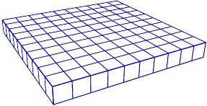
Note:

= 1 whole
N 3.1 Representing Number
11) What whole number is represented here? 2 347
Note:

= 1 whole
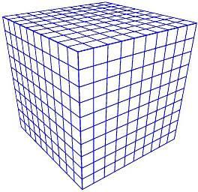
N 4.1 Representing Number
12) Order these numbers from least to greatest.
8 104
738
8 279
5 951

738 5 951 8 104 8 279
N 4.1 Place Value
13) Fill in the blanks (Continue the pattern)

754, 764, 774, 784, 794, 804, 814

N3.1, N4.1 Place Value
14) How much money? $1.95 or a dollar ninety-five
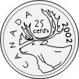

N3.1 Whole numbers (money) , N4.1 Decimals to hundredths (money)
15) Skip count by 3.  __3__ 6 9 12 15 |  | 16) Skip count by 10 starting at 22.  __22_ _32__ _42__ __52___ __62___ 72
N3.1 Whole numbers |  | N3.1 Whole numbers
17) Estimate the sum of the following.  Show your strategy.  795 + 112  800 + 100 = 900  Students can be prompted to use an algorithm but it will be interesting to note if they know to do that or if they have other strategies |  | 18) Add. 5 341 + 3 201 =  8 542
N3.2 N4.2 Estimation |  | N4.2 Add (no regrouping)

19) Add.  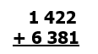  7 803 | 20) Subtract.  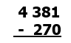  4 111
N4.2 Add (regrouping) | N4.2 Subtract (No regrouping)
21) Subtract. Students can be prompted to use an algorithm but it will be interesting to note if they know to do that or if they have other strategies  4 634 − 2 581 =  1 053 | 22) Rewrite 3+3+3+3 as a multiplication sentence.  _____ X _____ = _____  3 x 4 = 12 or 4 x 3 = 12
N4.1 Subtract (Regrouping) | N 3.3 Multiplication as repeated addition
23) 5 X 2 = 10  Write the related division sentence.  ______ ÷_____ = _____  10 $÷$ 5 = 2 or 10 $÷$ 2 = 5 | 24) Divide.  20 ÷ 5 =  4 | 25) Multiply.  9 X 6= 54
N 3.3 Relating multiplication and division | N3.3 Division | N4.3 Multiplication facts
26) Multiply.  5 X 7= 35 | 27) Multiply.  3 x 15 = 45
N4.3 Multiplication facts | N4.3 Multiplication
28) What multiplication sentence could represent this array?  5 x 4 = 20 or 4 x 5 = 20 | 29) What division sentence does this array represent?  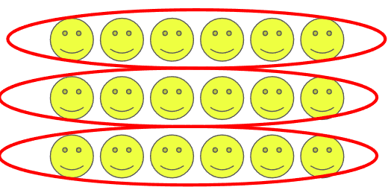  18 $÷$ 3 = 6 or 18 $÷$ 6 = 3
N 3.3 N4.4 Representing Multiplication, array | N4.5 Representing Division, array
30) There are 22 crayons to be shared equally by 4 students. How many crayons can each student get? Are there any left over?

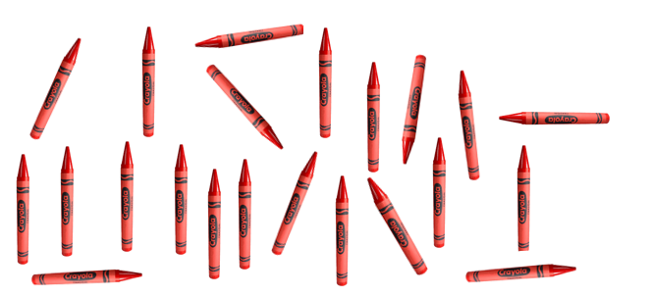
Everyone gets 5 with 2 left over

N4.5 Division with remainder using model
31) Multiply.  4 × 675 = 2 700 | 32) Multiply.  400 x 7 = 2 800
N4.4 Multiply 3 digit by 1 digit | N4.4 Multiply 3 digit by 1 digit
33) Divide.  72 ÷ 9 = 8 | 34) Divide. Students can be prompted to use an algorithm but it will be interesting to note if they know to do that or if they have other strategies  37 ÷ 3 = 12 r1
N 4.5 Divide | N 4.5 Divide with remainder
35) Estimate.  623 - 196  600 - 200 = 400 | 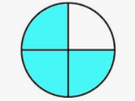  36) Name the fraction. $\frac{3}{4}$ | 37) There are 16 triangles. Circle $\frac{7}{16}$. Any seven, even individually circled is correct
N4.4 Estimate sums | N 3.4 Representing fraction | N3.4 Fraction
38) Shade $\frac{4}{5}$ of this chocolate bar  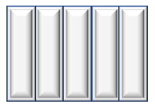 | 39)  3  8  Draw a picture to show .
N 4.6 Fraction | N 4.6 Fraction
40) Insert either < , >, or = between these two fractions.  3  9  7  9  <  < |  | 41) Circle the larger fraction.  3  6  3  4
N3.4 Fraction, compare |  | N4.6 Fraction, compare
42) What fraction of these items is ball gloves?  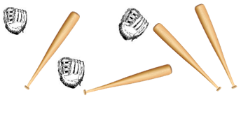  $\frac{3}{7}$ | 43) This hundredths grid represents one whole.  Express the shaded part as a decimal.  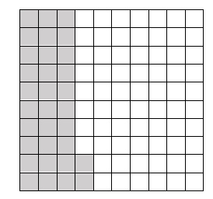  0.32
N4.6 Fraction of a set | N4.7 Decimals to hundredths
44) State the value of the underlined digit  6.47 four tenths or 4 tenths or 4/10  If a student just says “tenths”, prompt them to state how many tenths | 45) Put <, >, or = in the box  8.64 < 8.9
N4.7 Decimals to hundredths | N4.7 Understanding decimal
46) Put <, >, or = in the box  3.9 = 3.90 | 47)  7  10  Write as a decimal. 0.7
N4.7 Understanding decimal | N4.4 Decimals
48) Add.  5.63 + 2.8  Again, if students are stuck or  have no strategies, they can be  prompted to use an algorithm | 49) Add. 23.28  $10.72  +$12.56
N4.8 Decimals to hundredths, add | N4.8 Decimals to hundredths, add (with regrouping)
50) Subtract. 2.73  4.8 – 2.43 | 51) What number does the triangle represent? 8  6 + = 14
N4.8 Decimals to hundredths, subtract | P3.2 Equations

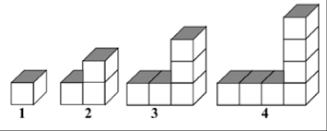
52) Extend the chart for the pattern of blocks.
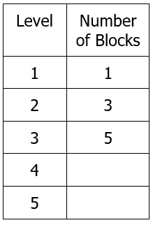
Chart
9
7
P4.1 Patterns, Missing elements in a chart
For all equation questions, if students simply report an answer, like “6” or ‘the number is 6”, prompt them to write the equation. If they are unable, then the item is incorrect
53) Write an equation with a variable to show  five groups of a number is 30.  5n=30 or 5 x n = 30 |  | 54) Write an equation with a variable to show a number is 4 less than 25. x = 25 – 4 or  25 – 4 = x
P4.2 Equations |  | P4.2 Equations
55) Four friends each bought a package of game cards. All together they have 32 cards. Write an equation using the variable x to represent how many cards are in each package.  4x=32 or 4 x x=32 |  | 56) Write an equation with a variable for 7 more than a number is 18.  7 + x=18 or 18= 7 + x
P4.2 Equations |  | P4.2 Equations
57) Find the perimeter of the garden:  P = 22 m  8m  3m  8m  3m |  | 58)  What is the area of this rectangle?  A = 15 cm²  3cm  5cm
SS3.3 Perimeter (rectangle) |  | SS4.2 Area (rectangle)
59) The area of this rectangle is 24m², what could the length and width be? | 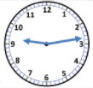  60) What time is it? 9:13 (or close to that) |  | 61) How many people chose comedy as their favorite type of movie? 4 people  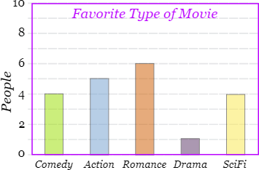
SS4.2 Area (rectangle) | SS 4.1 Time |  | SP3.1 SP4.1 Bar Graph

