Christ the Teacher Grade 5 Screener E1 Name__________________

How do you feel about Math? Circle one

Recall: We can represent a number several ways
Standard Form | Expanded form | Word form
6 458 | 6000 + 400 + 50 + 8 | six thousand four hundred fifty-eight

1) Write 6 902 in word form.
N4.1 Representing Number
2) Write 700 + 60 + 2  in standard form. | 3) Write the number nine hundred thirty-seven in standard form.
N3.1 Representing Number | N3.1 Representing Number
4) Write the number nine thousand twenty-eight in standard form. | 5) Write the value of the underlined digit.  526
N4.1 Representing Number | N3.1 Place value
6) Write the value of the underlined  digit.  4 904 | 7) Write a number greater than 3 450 and less  than 4 000.
N4.1 Place value | N4.1 Place value
8) Write the number 9 067 in expanded form.
N3.1 N4.1 Representing Number
9) Fill in the blanks to continue the counting pattern:

997 , 998 , _______ , _______ , _______

N 4.1 Representing Number, Place Value
10) What whole number is represented here?
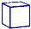
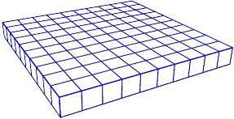
Note:

= 1 whole
N 3.1 Representing Number
11) What whole number is represented here?
Note:

= 1 whole
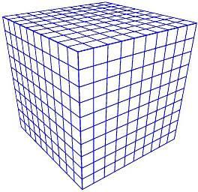
N 4.1 Representing Number
12) Order these numbers from least to greatest.
8 104
738
8 279
5 951

___________ ___________ ___________ ___________
N 4.1 Place Value
13) Fill in the blanks (Continue the pattern)

754, 764, 774, 784, _________ , _________ , __________

N3.1, N4.1 Place Value
14) How much money?
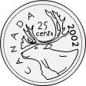
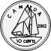
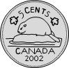

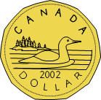

N3.1 Whole numbers (money) , N4.1 Decimals to hundredths (money)
15) Skip count by 3.  __3__ _____ _____ _____ _____ _____ |  | 16) Skip count by 10 starting at 22.  __22_ _____ _____ _____ _____ _____
N3.1 Whole numbers |  | N3.1 Whole numbers
17) Estimate the sum of the following.  Show your strategy.  795 + 112 |  | 18) Add. 5 341 + 3 201 =
N3.2 N4.2 Estimation |  | N4.2 Add (no regrouping)

19) Add.  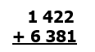 | 20) Subtract.  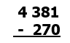
N4.2 Add (regrouping) | N4.2 Subtract (No regrouping)
21) Subtract.  4 634 − 2 581 = | 22) Rewrite 3+3+3+3 as a multiplication sentence.  _____ X _____ = _____
N4.1 Subtract (Regrouping) | N 3.3 Multiplication as repeated addition
23) 5 X 2 = 10  Write the related division sentence.  ______ ÷_____ = _____ | 24) Divide.  20 ÷ 5 = | 25) Multiply.  9 X 6=
N 3.3 Relating multiplication and division | N3.3 Division | N4.3 Multiplication facts
26) Multiply.  5 X 7= | 27) Multiply.  3 x 15 =
N4.3 Multiplication facts | N4.3 Multiplication
28) What multiplication sentence could represent this array? | 29) What division sentence does this array represent?  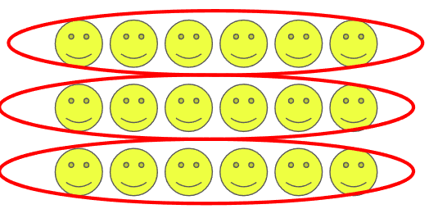
N 3.3 N4.4 Representing Multiplication, array | N4.5 Representing Division, array
30) There are 22 crayons to be shared equally by 4 students. How many crayons can each student get? Are there any left over?

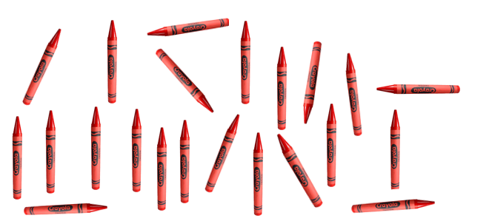

N4.5 Division with remainder using model
31) Multiply.  4 × 675 = | 32) Multiply.  400 x 7 =
N4.4 Multiply 3 digit by 1 digit | N4.4 Multiply 3 digit by 1 digit
33) Divide.  72 ÷ 9 = | 34) Divide. Show remainder.  37 ÷ 3 =
N 4.5 Divide | N 4.5 Divide with remainder
35) Estimate.  623 - 196 | 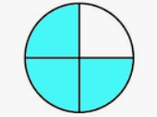  36) Name the fraction. | 37) There are 16 triangles. Circle $\frac{7}{16}$.
N4.4 Estimate sums | N 3.4 Representing fraction | N3.4 Fraction
38) Shade $\frac{4}{5}$ of this chocolate bar  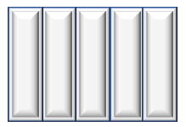 | 39)  3  8  Draw a picture to show .
N 4.6 Fraction | N 4.6 Fraction
40) Insert either < , >, or = between these two fractions.  3  9  7  9 |  | 41) Circle the larger fraction.  3  6  3  4
N3.4 Fraction, compare |  | N4.6 Fraction, compare
42) What fraction of these items is ball gloves?  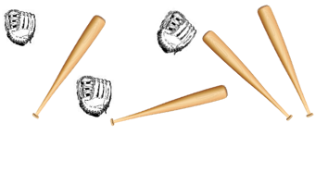 | 43) This hundredths grid represents one whole.  Express the shaded part as a decimal.  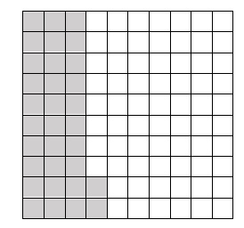
N4.6 Fraction of a set | N4.7 Decimals to hundredths
44) State the value of the underlined digit  6.47 | 45) Put <, >, or = in the box  8.64 8.9
N4.7 Decimals to hundredths | N4.7 Understanding decimal
46) Put <, >, or = in the box  3.9 3.90 | 47)  7  10  Write as a decimal.
N4.7 Understanding decimal | N4.4 Decimals
48) Add.  5.63 + 2.8 | 49) Add.  $10.72  +$12.56
N4.8 Decimals to hundredths, add | N4.8 Decimals to hundredths, add (with regrouping)
50) Subtract.  4.8 – 2.43 | 51) What number does the triangle represent?  6 + = 14
N4.8 Decimals to hundredths, subtract | P3.2 Equations

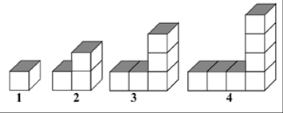
52) Extend the chart for the pattern of blocks.
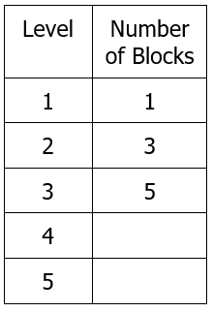
Chart
P4.1 Patterns, Missing elements in a chart
53) Write an equation with a variable to show  five groups of a number is 3. |  | 54) Write an equation with a variable to show a number is 4 less than 25.
P4.2 Equations |  | P4.2 Equations
55) Four friends each bought a package of game cards. All together they have 32 cards. Write an equation using the variable x to represent how many cards are in each package. |  | 56) Write an equation with a variable for 7 more than a number is 18.
P4.2 Equations |  | P4.2 Equations
57) Find the perimeter of the garden:  8m  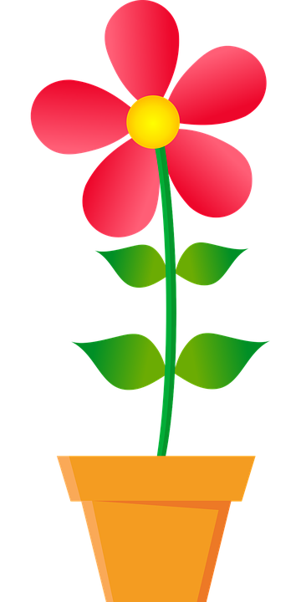  3m  8m  3m |  | 58)  What is the area of this rectangle?  3cm  5cm
SS3.3 Perimeter (rectangle) |  | SS4.2 Area (rectangle)
59) The area of this rectangle is 24m², what could the length and width be? | 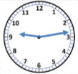  60) What time is it? |  | 61) How many people chose comedy as their favorite type of movie?  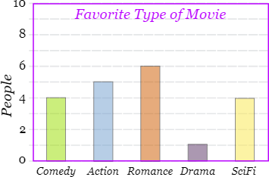
SS4.2 Area (rectangle) | SS 4.1 Time |  | SP3.1 SP4.1 Bar Graph

