Christ the Teacher Grade 6 Screener F1 Name_____KEY_____________
How do you feel about Math? Circle one.

Recall: We can represent a number several ways
Standard Form | Expanded form | Word form
86 458 | 80 000 + 6000 + 400 + 50 + 8 | Eighty-six thousand four hundred fifty-eight

- Write 301 982 in word form. Three hundred one thousand nine hundred eighty-two
N 5.1 Representing Number
2)  Write 40 000 + 3 000 + 700 + 60 + 2  in standard form.  43 762 | 3) Write the number seven hundred fifty-six thousand nine hundred thirty-seven in standard form. 756 937
N 5.1 Representing Number | N5.1 Representing Number
4) Write the number three million two hundred thirty-nine thousand thirty-seven in standard form.  3 239 037 | 5) Write the value of the underlined digit.  34 904 Nine hundred or 9 hundred  If the student writes 900 prompt them to write it in words
N5.1 Representing Number | N4.1 N5.1 Place value
6) Write the value of the underlined digit.  621 384  Six hundred thousand  Or 6 hundred thousand  If the student writes 600 thousand or 600 000, prompt them to write it in words | 7) Write a number greater than 387 450 and less than 400 000.  Anything in the range:  387 451 – 399 999
N5.1 Place value | N5.1 Place value
8) Write the number 3 605 084 in expanded form.
3 000 000 + 600 000 + 5 000 + 80 + 4
If a student includes the zeros in the ten thousands or hundreds position, have a conversation but consider entering this item as correct
N 5.1 Representing Number
9) Fill in the blanks to continue the counting pattern.

27 997 , 27 998 , 27 999, 28 000, 28 001

N 4.1, N5.1 Representing Number, Place Value
10) Write the number that is represented by these base ten blocks in standard form.
Note:
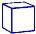 = 1 whole
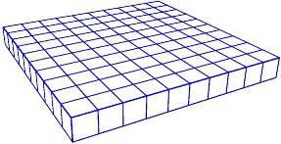
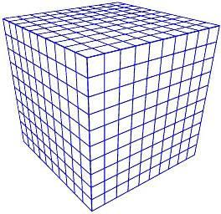
2 347
N 4.1 N 5.1 Representing Number
11) Order these numbers from least to greatest.
665 104
99 856
800 279
618 951

99 856 618 951 665 104 800 279
N 5.1 Place Value
12) Fill in the blanks (Continue the pattern).
8 452, 8 462, 8 472, 8 482, 8 492 8 502 8 512
N4.1, N5.1 Place Value

13) Estimate the sum of the following. Show your strategy.
1 395 + 5 722 1 000 + 6 000 = 7 000 or 1400 + 5800 = 7200 or similar
If a student calculates or calculates then rounds that is incorrect. If students use an equal sign in an estimation, have a corrective convseration

N4.2 N5.4 Estimation
14) Add 15 341 + 13 201 = 28 542 Students can use an algorithm if they like

N5.4 Add (no regrouping)
15) Add.  341 422  + 298 381  639 803 |  | 16) Subtract.  867 386  - 13 270  856 116
N5.4 Add (regrouping) |  | N5.4 Subtract (No regrouping)
17) Subtract.  234 634 − 48 581 =  186 053  Students can use an algorithm if they like.I’ts ok to prompt them as they may not realize this is allowed, but it will be interesting to see what strategies they apply |  | 18) Multiply.  5 X 4= 20 |  | 19) Multiply.  9 X 6= 54
N 4.1 Subtract (Regrouping) |  | N 4.3 Multiplication facts |  | N 4.3 Multiplication facts
20) Divide.  40 ÷ 8 = 5 | 21) Divide.  42 ÷ 6 =7 |  | 22) Multiply.  3 x 15 =45
N5.5 Division | N5.5 Division |  | N 4.3 Multiplication
23) Multiply.  4 × 675 =2700  Students can use an algorithm if they like.I’ts ok to prompt them as they may not realize this is allowed, but it will be interesting to see what strategies they apply | 24) Multiply.  22 x 33 =726  Students can use an algorithm if they like.I’ts ok to prompt them as they may not realize this is allowed, but it will be interesting to see what strategies they apply
N 4.4 Multiply 3 digit by 1 digit | N 5.2 Multiply 2 digit by 2 digit
25) Find the product.  45 x 1000 = 45 000  If students need an algorithm here, make a note to reteach multiplying by factors of ten | 26) Divide.  72 ÷ 6 = 12
N 5.2 Multiplying by factors of ten | N 4.5 Divide no remainder
27) Divide.  37 ÷ 3 = 12r1 | 28) Divide.  245 ÷ 5 = 49
N 4.5 Divide with remainder | N 5.3 Divide 3 digit by 1 digit no remainder

29) Divide. Use any strategy you like.  315 ÷ 4 = 78 r 3  Students may be prompted to use the algorithm. Some may proceed to decimal | 30) Divide. Show your remainder. 145 r 4  5 729
N 5.3 Divide 3 digit by 1 digit with remainder | N 5.3 Division 3 digit by 1 digit with remainder Strategy
31) Estimate the product.  18 × 72  20 x 70 = 1400  IF students calculate, this item is incorrect. If students put an = sign in an estimation, have a conversation Ex 18 x 72 = 1400 | 32) Estimate the quotient.  198 ÷ 4  IF students calculate, this item is incorrect. If students put an = sign in an estimation, have a conversation Ex 198/4 =  200/4=50
N 5.4 Estimate (Compensation) | N 5.4 Estimate (Front End Rounding)
33) Shade $\frac{4}{5}$. | 34) Draw a picture to show$\frac{3}{8}$
N 4.6 Fraction | N 4.6 Fraction
35) Place these three fractions on approximately where they go on the number line. Students may want to make a common denom and draw exact tic marks. Prompt them to use logic and show a sense of number
1
10
3
4
1
3
$$\frac{1}{2}$$
1
0

1
N 5.5 Fraction
36) Circle the larger fraction  3  6  3  4  ​᠎​​᠎​ | 37) Insert either < , >, or = between these two fractions  2  5  5  9
N 4.6 Fraction, compare | N 5.5 Fraction, compare
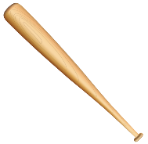  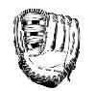  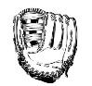  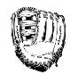  38) This is the sports equipment in a gym locker. What fraction of this set of items are ball gloves? 3/7 | 39) Split this chocolate bar into fourths.  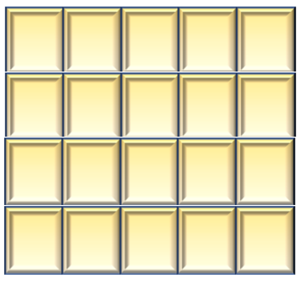
N 4.6 Fraction of a set | N 5.5 Fraction
40) This hundredths grid represents one whole.
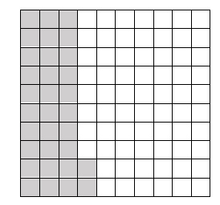
Express the shaded part as a decimal. 0.32

N 4.7 Decimals to hundredths

41) This thousandths grid represents one whole. Express the shaded part as a decimal 0.892

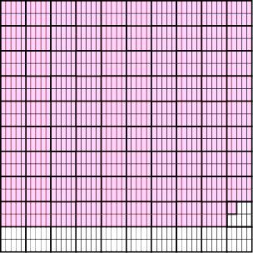

N 5.6 Decimals to thousandths
42)  7  Write as a decimal  10  0.7 | 43) Add.  $10.32  +$12.56  22.88 |  |  | 44) Add.  366.298 + 53.74=420.038  Students may be prompted to use the algorithm. IF they don’t know to line up decimals, this is incorrect
N 4.4 Decimals | N4.8 Decimals to hundredths, add (no regrouping, money) |  |  | N5.7 Decimals to thousandths, add (regrouping)
45) What multiplication sentence could represent this array?  5 x 4 or 4 x 5 |  |  | 46) What division sentence does this array represent?  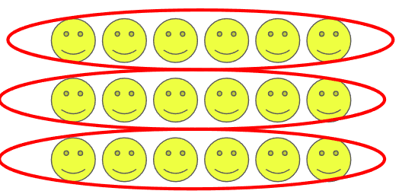  18 $÷$ 3 = 6 or 18 $÷$6 = 3
N4.4 Representing Multiplication, array |  |  | 4.5 Representing Division, array
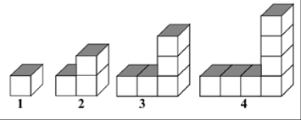
47) Extend the chart for the block pattern. Chart
For the “write an equation” question, if a student just gives an “answer” show them that we are looking for an algebraic sentence. If they can’t do this, but can compute the result, it’s still incorrect
Level | Number of Blocks
1 | 1
2 | 3
3 | 5
4 | 7
5 | 9

P 4.1 Patterns, Missing elements in a chart
48) Write an equation with a variable for:  5 groups of a number is 30.  5x=30 If a student writes “6” or “the number is 6”, prompt them to write the equation. If they can’t, this item is incorrect |  | 49) Write an equation with a variable for 12 is 4 less than a number. 12 = x – 4 or x – 4 = 12
4.2, 5.2 Equations |  | P 4.2, 5.2 Equations
50) Four friends each bought a package of game cards. All together they have 64 cards. Write an equation using the variable x to represent how many cards are in each package.  4x = 64 or 4 x x = 64 |  | 51) Write an equation with a variable for  7 more than a number is 18.
P 4.2, 5.2 Equations |  | P 4.2, 5,2 Equations
52) Solve for n  $$n + 6= 14$$  n = 8 |  | 53) Solve for x  $x = 6 4 x = 24$
P5.2 Equations |  | P5.2 Equations
54) The area of this rectangle is 24m², what could the length and width be? |  | 55) What is the area of this rectangle?  5cm  3cm  15cm²
SS4.2, 5.1 Area (rectangle) |  | SS 4.2 Area (rectangle)
56) Find the perimeter of the garden: 40 m
12m

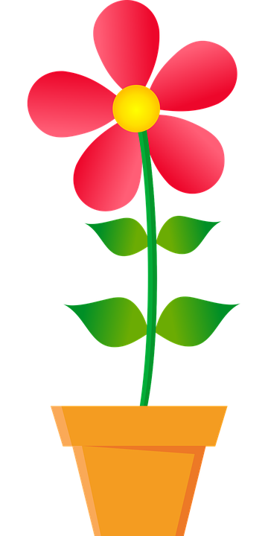
8m
SS 5.1 Perimeter (rectangle)
57) How many people chose comedy as their favorite type of movie? 4 people  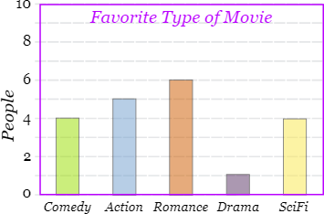 |  | 58) How many people bought ice cream during the second week of August? 900 people  Ice cream sold in July and August  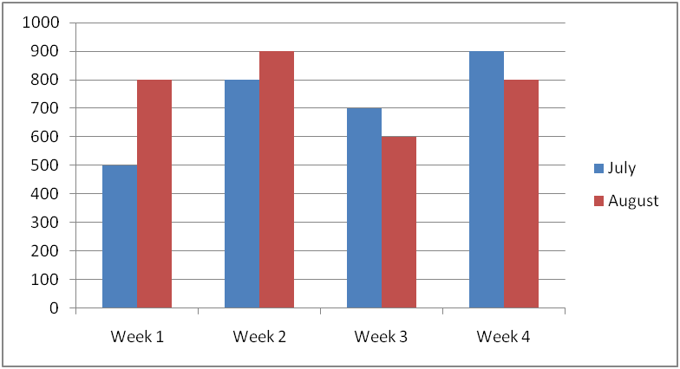
SP4.1 Bar Graph |  | SP5.2 Double Bar Graph
For SS questions, if students don’t include units, remind them but make a note. If they don’t understand the exponent on units, reteach. As long as numerical computation is correct you may consider marking the item correct

