Christ the Teacher Grade 6 Screener F1 Name__________________
How do you feel about Math? Circle one.

Recall: We can represent a number several ways
Standard Form | Expanded form | Word form
86 458 | 80 000 + 6000 + 400 + 50 + 8 | Eighty-six thousand four hundred fifty-eight

- Write 301 982 in word form.
N 5.1 Representing Number
2)  Write 40 000 + 3 000 + 700 + 60 + 2  in standard form. | 3) Write the number seven hundred fifty-six thousand nine hundred thirty-seven in standard form.
N 5.1 Representing Number | N5.1 Representing Number
4) Write the number three million two hundred thirty-nine thousand thirty-seven in standard form. | 5) Write the value of the underlined digit.  34 904
N5.1 Representing Number | N4.1 N5.1 Place value
6) Write the value of the underlined digit.  621 384 | 7) Write a number greater than 387 450 and less than 400 000.
N5.1 Place value | N5.1 Place value
8) Write the number 3 605 084 in expanded form.
N 5.1 Representing Number
9) Fill in the blanks to continue the counting pattern.

27 997 , 27 998 , ___________ , _____________ , ____________

N 4.1, N5.1 Representing Number, Place Value
10) Write the number that is represented by these base ten blocks in standard form.
Note:
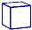 = 1 whole
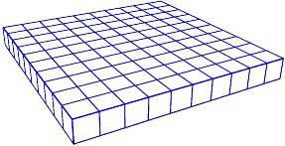
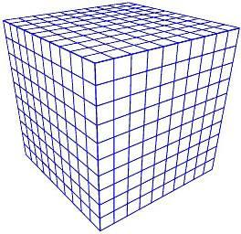
N 4.1 N 5.1 Representing Number
11) Order these numbers from least to greatest.
665 104
99 856
800 279
618 951

N 5.1 Place Value
12) Fill in the blanks (Continue the pattern).
8 452, 8 462, 8 472, 8 482, _______________ , _________________ , ________________
N4.1, N5.1 Place Value

13) Estimate the sum of the following. Show your strategy.
1 395 + 5 722

N4.2 N5.4 Estimation
14) Add 15 341 + 13 201 =

N5.4 Add (no regrouping)
15) Add.  341 422  + 298 381 |  | 16) Subtract.  867 386  - 13 270
N5.4 Add (regrouping) |  | N5.4 Subtract (No regrouping)
17) Subtract.  234 634 − 48 581 = |  | 18) Multiply.  5 X 4= |  | 19) Multiply.  9 X 6=
N 4.1 Subtract (Regrouping) |  | N 4.3 Multiplication facts |  | N 4.3 Multiplication facts
20) Divide.  40 ÷ 8 = | 21) Divide.  42 ÷ 6 = |  | 22) Multiply.  3 x 15 =
N5.5 Division | N5.5 Division |  | N 4.3 Multiplication
23) Multiply.  4 × 675 = | 24) Multiply.  22 x 33 =
N 4.4 Multiply 3 digit by 1 digit | N 5.2 Multiply 2 digit by 2 digit
25) Find the product.  45 x 1000 = | 26) Divide.  72 ÷ 6 =
N 5.2 Multiplying by factors of ten | N 4.5 Divide no remainder
27) Divide.  37 ÷ 3 = | 28) Divide.  245 ÷ 5 =
N 4.5 Divide with remainder | N 5.3 Divide 3 digit by 1 digit no remainder

29) Divide. Use any strategy you like.  315 ÷ 4 = | 30) Divide. Show your remainder.  5 729
N 5.3 Divide 3 digit by 1 digit with remainder | N 5.3 Division 3 digit by 1 digit with remainder Strategy
31) Estimate the product.  18 × 72 | 32) Estimate the quotient.  198 ÷ 4
N 5.4 Estimate (Compensation) | N 5.4 Estimate (Front End Rounding)
33) Shade $\frac{4}{5}$. | 34) Draw a picture to show$\frac{3}{8}$
N 4.6 Fraction | N 4.6 Fraction
35) Place these three fractions on approximately where they go on the number line.
1
10
3
4
1
3
$$\frac{1}{2}$$
1
0

1
N 5.5 Fraction
36) Circle the larger fraction  3  6  3  4  ​᠎​​᠎​ | 37) Insert either < , >, or = between these two fractions  2  5  5  9
N 4.6 Fraction, compare | N 5.5 Fraction, compare
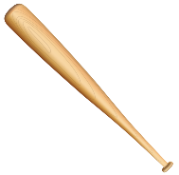  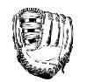  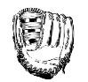  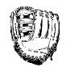  38) This is the sports equipment in a gym locker. What fraction of this set of items are ball gloves? | 39) Split this chocolate bar into fourths.  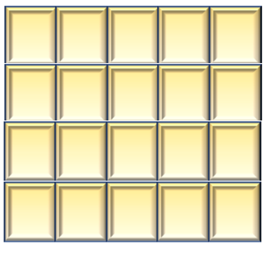
N 4.6 Fraction of a set | N 5.5 Fraction
40) This hundredths grid represents one whole.
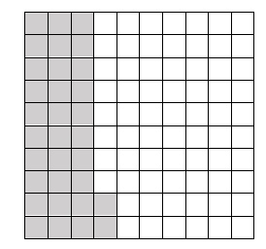
Express the shaded part as a decimal.

N 4.7 Decimals to hundredths

41) This thousandths grid represents one whole. Express the shaded part as a decimal.

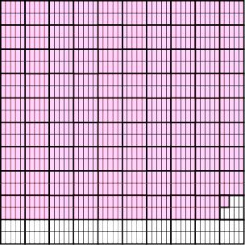

N 5.6 Decimals to thousandths
42)  7  Write as a decimal  10 | 43) Add.  $10.32  +$12.56 |  |  | 44) Add.  366.298 + 53.74=
N 4.4 Decimals | N4.8 Decimals to hundredths, add (no regrouping, money) |  |  | N5.7 Decimals to thousandths, add (regrouping)
45) What multiplication sentence could represent this array? |  |  | 46) What division sentence does this array represent?  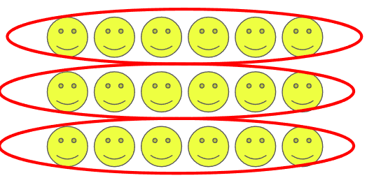
N4.4 Representing Multiplication, array |  |  | 4.5 Representing Division, array
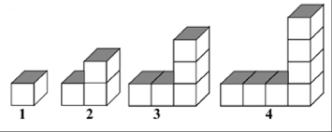
47) Extend the chart for the block pattern. Chart
Level | Number of Blocks
1 | 1
2 | 3
3 | 5
4
5

P 4.1 Patterns, Missing elements in a chart
48) Write an equation with a variable for:  5 groups of a number is 30. |  | 49) Write an equation with a variable for 12 is 4 less than a number.
4.2, 5.2 Equations |  | P 4.2, 5.2 Equations
50) Four friends each bought a package of game cards. All together they have 64 cards. Write an equation using the variable x to represent how many cards are in each package. |  | 51) Write an equation with a variable for  7 more than a number is 18.
P 4.2, 5.2 Equations |  | P 4.2, 5,2 Equations
52) Solve for n  $$n + 6= 14$$ |  | 53) Solve for x  $4 x = 24$
P5.2 Equations |  | P5.2 Equations
54) The area of this rectangle is 24m², what could the length and width be? |  | 55) What is the area of this rectangle?  5cm  3cm
SS4.2, 5.1 Area (rectangle) |  | SS 4.2 Area (rectangle)
56) Find the perimeter of the garden:
12m

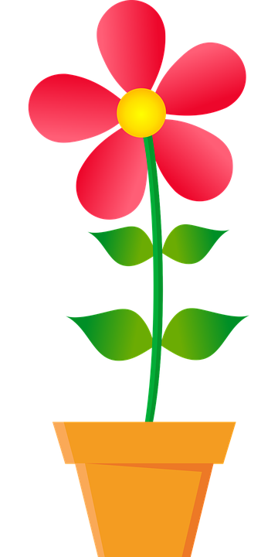
8m
SS 5.1 Perimeter (rectangle)
57) How many people chose comedy as their favorite type of movie?  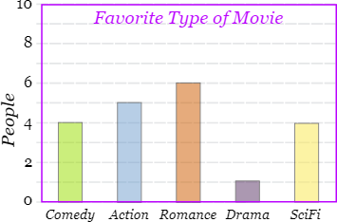 |  | 58) How many people bought ice cream during the second week of August?  Ice cream sold in July and August  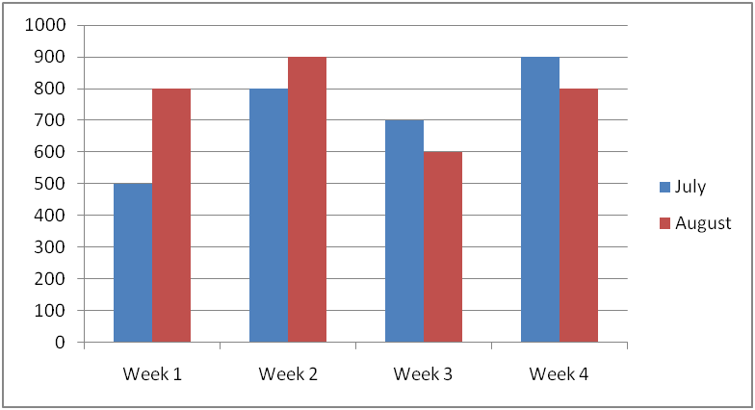
SP4.1 Bar Graph |  | SP5.2 Double Bar Graph

