Christ the Teacher Grade 7 Screener G1 Name__________________

How do you feel about Math? Circle one.

Recall: We can represent a number several ways
Standard Form | Expanded form | Word form
86 458 | 80 000 + 6000 + 400 + 50 + 8 | Eighty-six thousand four hundred fifty-eight

1) Write 301 982 in word form.
N 5.1 Representing Number
2) Write 40 000 + 3 000 + 700 + 60 + 2
in standard form.

N5.1 Representing Number
3) Write the number seven hundred fifty-six thousand nine hundred thirty-
seven in expanded form
N 5.1 Representing Number
4) Write the number three million two hundred thirty-nine thousand thirty-seven in standard form. | 5) Write the value of the underlined digit.  62 421 384
N6.1 Representing Number | N6.1 Place value

6)  Write the value of the underlined digit in words or fraction form.  81.375 | 7) Write a number greater than 4.1 and  less than 4.2
N6.1 Place Value Decimal | N5.1 Place value
8) Write the number 2.3 billion in standard form

N6.1 Place Value
9) Fill in the blanks to continue the counting pattern:

54 997 , 54 998 , ___________ , _____________ , ____________

N5.1 Representing Number, Place Value
10) Write the number that is represented by these base ten blocks in standard form.
Note:
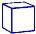 = 1 whole
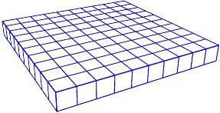
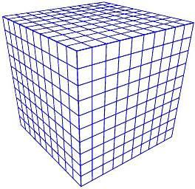
N 5.1 Representing Number
11) Order these numbers from least to greatest.
665 104
99 856
800 279
618 951

N 5.1 Place Value
12) Fill in the blanks (Continue the pattern)
8 452, 8 462, 8 472, 8 482, _______________ , _________________ , ________________
N5.1 Place Value
13) Estimate the sum of the following. Show your strategy.
3 395 + 4 623

N5.4 Estimation
14) Add 15 341 + 13 201 =

N5.4 Add (no regrouping)
15) Add  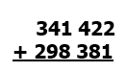 | 16) Subtract  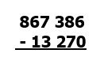 |  |  |  | 17) Subtract  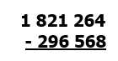
N5.4 Add (regrouping) | N5.4 Subtract (No regrouping) |  |  |  | N5.4 Subtract (regrouping)
18) Multiply.  22 x 33 = | 19) Find the product.  45 x 1000 = |  |  |  |  | 20) Divide.  40 ÷ 8 =
N 5.2 Multiply 2 digit by 2 digit | N 5.2 Multiplying by factors of ten |  |  |  |  | N5.5 Division
21) Divide. Show your remainder.  5 729 |  | 22) Divide.  245 ÷ 5 = |  | 23) What is the greatest common factor of 48, 16 and 40?
N 5.3 Division 3 digit by 1 digit with remainder Strategy |  | N 5.3 Divide 3 digit by 1 digit no remainder |  | N6.2 Factors and Multiples
24) Estimate the product:  18 × 72 |  |  | 25) Estimate the quotient:  198 ÷ 4
N 5.4 Estimate (Compensation) |  |  | N 5.4 Estimate (Front End Rounding)
26) What is the least common multiple of 3,4, and 6? | 27) Circle all the prime numbers  10 15 17 5 21 29 11
N6.2 Factors and Multiples | N6.2 Factors and Multiples
28) Use any method you like to write all the prime factors of 36 | 29) Calculate  $$10÷2+3×\left(9-2\right)=$$
N6.2 Factors and Multiples | N 6.3 Order of Operations
30) Place these three fractions on the number line.
1
3
3
4
1
10
1
$$\frac{1}{2}$$
0
1
N 5.5 Fraction
31) Place these three fractions on the number line.
$\frac{7}{20}$ 1$\frac{1}{4}$ $\frac{15}{10}$

N 6.7 Fractions
32) Split this chocolate bar into fourths.  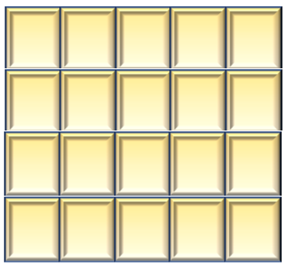 | 33) Insert either < , >, or = between these two fractions  2  5  5  9
N 5.5 Fraction | N 5.5 Fraction, compare
34) Change to a mixed number | 35) Write as an improper fraction (common fraction) | 36) Write in lowest terms (reduce/simplify)  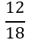
N6.7 Fractions | N6.7 Fractions | N6.7 Fractions
37) This thousandths grid represents one whole. Express the shaded part as a decimal.  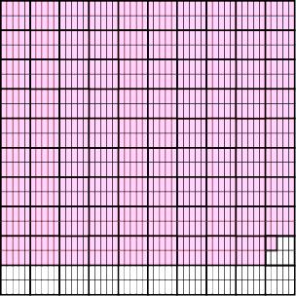 |  |  |  |  |  |  |  | 38) Add.  $366.298 + 53.74$
N 5.6 Decimals to thousandths |  |  |  |  |  |  |  | N5.7 Decimals to thousandths, add (regrouping)
39) Place the decimal where it belongs in this product  $$16.324 ×3.15=514206$$ |  |  |  |  |  |  | 40) Place the decimal where it belongs in this quotient  $$42.539 ÷5.15= 826$$
N 6.4Mult and Div of decimals |  |  |  |  |  |  | N 6.4Mult and Div of decimals
41)Find the product  $$0.89$$  $$×6$$ | 42)Divide (do not leave a remainder)  $$24.025 ÷ 5 =$$ |  |  |  |  |  |  |  |  | 43) Shade 18% of this hundred grid  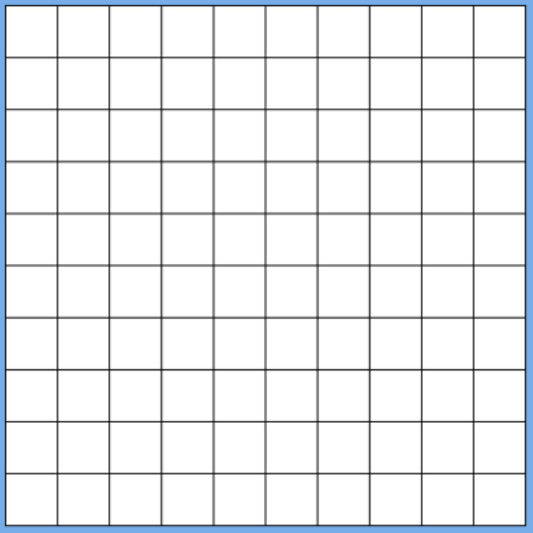
N 6.4Mult and Div of decimals | N 6.4Mult and Div of decimals |  |  |  |  |  |  |  | N 6.5 Percent
44) What percent of this shape is shaded?  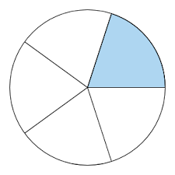 |  | 45) Express 35% as a fraction |  |  |  |  |  |  | 46) Insert either < , >, or = between these two integers  -6 -10
N 6.5 Percent |  | N 6.5 Percent |  |  |  |  |  |  | N6.6 Integers
47) Place these integers on the number line
+5 -5 +2 0 -4 +4

N6.6 Integers
48) What is the ratio of cars to trucks?  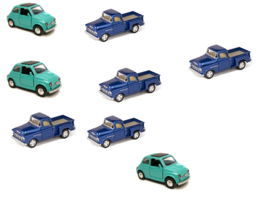 |  |  |  | 49) Write an equation with a variable for:  Five groups of a number is 30.
N6.8 Ratios |  |  |  | P5.2 Equations
50) Write an equation with a variable for 15 is 4 less than a number
P5.2 Equations
51) Four friends each bought a package of game cards. All together they have 64 cards. Write an equation using the variable x to represent how many cards are in each package. |  |  |  |  |  |  |  |  | 52)  Write an equation with a variable for seven more than a number is 18.
P5.2 Equations |  |  |  |  |  |  |  |  | P5.2 Equations
53) Solve for n.  $$n + 6= 14$$ |  |  | 54) Solve for x:  $4 x = 24$
P5.2 P6.2 Equations |  |  | P5.2 P6.2Equations
55) Write the rule with words or an equation

1 | 3
2 | 7
3 | 11
4 | 15
5 | 19

P6.1 Tables and Graphs
Figure number | Number of Blocks
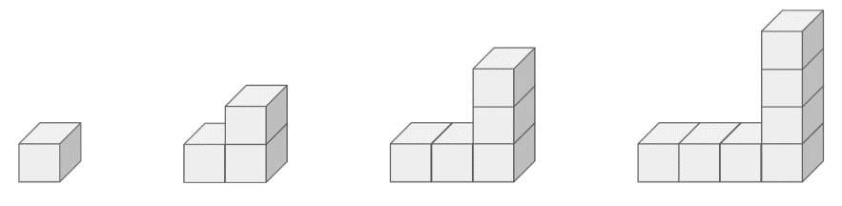
56) Create a table of values for this increasing pattern

Fig. 4
Fig. 3
Fig. 2
Fig. 1
P6.1 Tables and Graphs
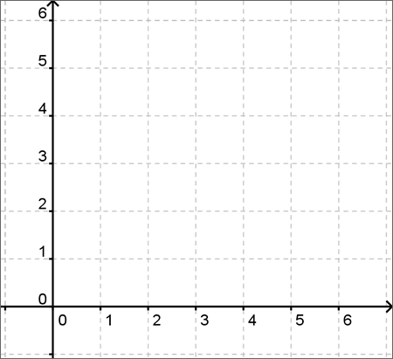  57) Plot the point (4,2) |  |  |  |  |  | Input Output  58) Create an input/output table  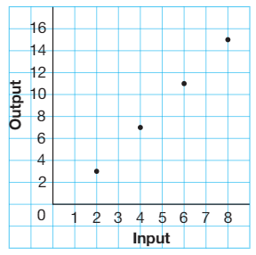
P6.1 Tables and Graphs SS6.4 Cartesian Plane |  |  |  |  |  | P6.1 Tables and Graphs
59) Write an equation to represent the rule for this table. Use C for cost and n for number of guests.
Number of Guests | Cost
1 | 20
2 | 40
3 | 60
5 | 100
n

N6.3 Patterns and Relations
60) The area of this rectangle is 24m², what could the length and width be? |  |  |  |  | 61) Find the perimeter of the garden:  12m  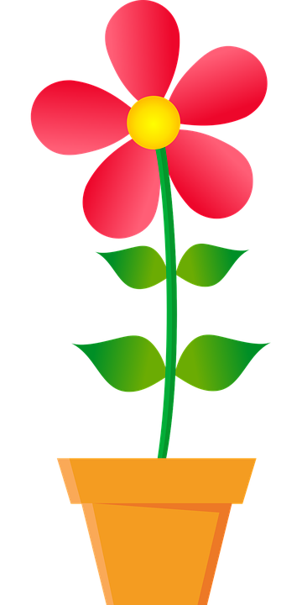  8m
SS5.1 Area (rectangle) |  |  |  |  | SS 5.1 Perimeter (rectangle)
62)Circle the angle that is about 45  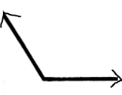  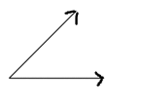 |  |  |  |  | 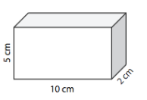  63) Find the volume
SS6.1 Angles |  |  |  |  | SS 6.2 Volume
64) How many people bought ice cream during the second week of August?  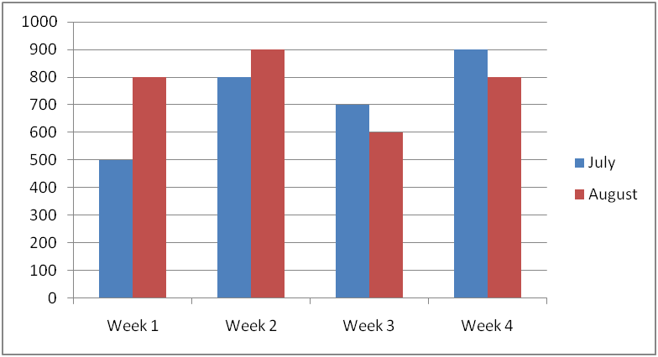  Ice cream sold in July and August |  |  |  |  | 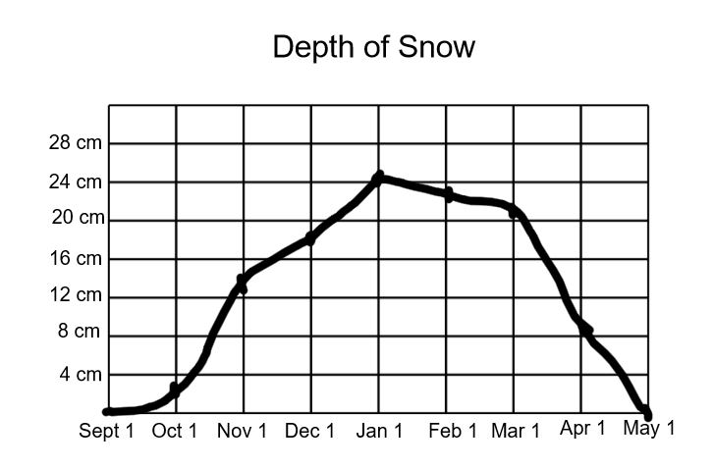  65) How deep was the snow on Dec 1?
SP5.2 Double Bar Graph |  |  |  |  | SP 6.1 Line graphs and data

