Christ the Teacher Grade 8 Screener H1 Name_________KEY_________
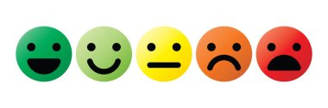
How do you feel about Math? Circle one

1) Write the value of the underlined digit.  62 421 384  Two million  2 million  If the student writes 2 000 000 ask them to read the number to you and/or write out the words | 2) Write the value of the underlined digit:  4.268451  Don’t worry about hyphen  Four ten-thousandths  4 ten-thousandths  4/10 000
N6.1 Place value | N 7.2 Place value/decimal
3) Circle all the numbers divisible by 3  135 65 355 54 9 | 4) All these numbers are divisible by what number?  5  15 45 90 10 125
N 7.1 Divisibility rules | N 7.1 Divisibility rules
5) Write the number 345 605 084 in expanded form.
300 000 000 + 40 000 000 + 5 000 000 + 600 000 + 5 000 + 80 + 4
If a student includes the zeros, like 00 000 for the ten thousands place or 000 for the hundreds place, you can have a conversation about that but don’t need to mark the answer wrong
N 6.1 Representing Number
6) Write the number 2.3 billion in standard form  2 300 000 000  This question is out of the curriculum guide | 7) What is the greatest common factor of 48, 16 and 40?  8
N 6.1 Representing Number | N6.2 Factors and Multiples
8) What is the least common multiple of 3,4, and 6?  12 (24, 72 are common multiples but not least common multiples) | 9) Circle all the prime numbers  10 15 17 5 21 29 11
N6.2 Factors and Multiples | N6.2 Factors and Multiples
10) Use any method you like to write all the prime factors of 36 | 11) Calculate  $$10÷2+3×(9-2)=$$
N6.2 Factors and Multiples | N 6.3 Order of Operations
12) Calculate  $12-0.5×1.2=$ | 13) Express as an improper fraction  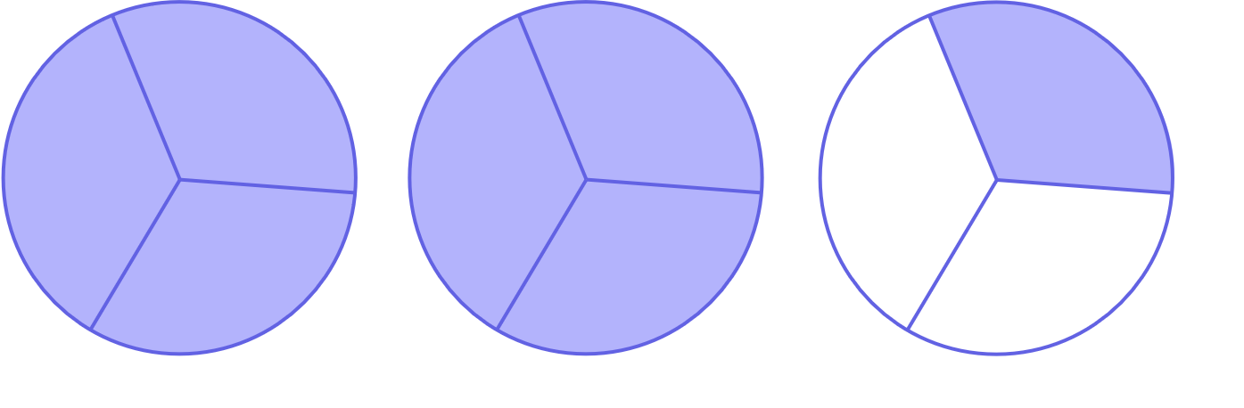  7/3
N 7.2 Order of Operations, decimals | N6.7 Fractions
14) Change to a mixed number  $2\frac{2}{3}$ | 15) Write as an improper fraction (common fraction)  $\frac{17}{5}$
N6.7 Fractions | N6.7 Fractions
16) Write in lowest terms (reduce/simplify)  $\frac{12}{18}$ $\frac{2}{3}$ | 17)  4.5 + 0.73 + 256.458=  You may need to prompt a student to stack in an algorithm, but if you have to remind them to line up the decimal points we can conclude the student doesn’t know or has forgotten the skill. Other methods are fine
N6.7 Fractions | N 7.2 Add Decimals
18)  6 – 3.682=  2.318 | 19) Place the decimal where it belongs in this product  $$16.324 ×3.15=51.4206$$
N 7.2 Add Decimals | N 6.4Mult and Div of decimals
20) Place the decimal where it belongs in this quotient

$$42.539 ÷5.15= 8.26$$
N 6.4Mult and Div of decimals
21) Find the product  0.891  ×16  14.256 | 22) Divide (do not leave a remainder)  24.025 ÷ 5 =  4.805
N 6.4, N 7.2 Mult and Div of decimals | N 6.4, N7.2 Mult and Div of decimals
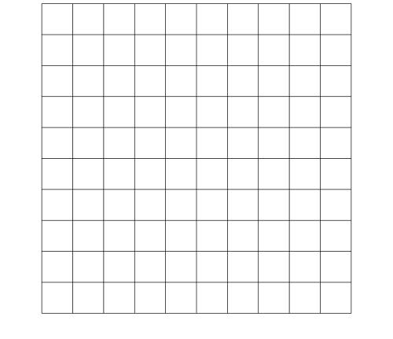  23) Shade 18% of this hundredths grid | 24) What percent of this shape is shaded?  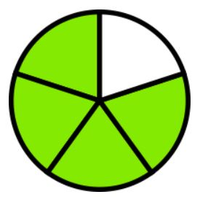  80%
N 6.5 Percent | N 6.5, N7.4 Percent and Fraction
25) Express 35% as a fraction  $\frac{35}{100}$ or $\frac{7}{20}$ By Gr 8 we would want our students to always reduce fractions but in this case we can accept 35/100. Math Makes Sense accepts answers like this. | 26) Write $3/100$ as a decimal.  0.03
N 6.5, N7.4 Percent and fraction | N 7.4 Fraction and Decimal
27) Write 0.72 as a percent  0.72 = ___72___% | 28) Write 0.04 as a percent  0.04 = __4____%
N 7.4 Decimal and Percent | N 7.4 Decimal and Percent
29) Write 0.145 as a percent  0.145 = ___14.5___% | 30) Order the following from least to greatest  0.56 3 1.4 1.389  3 __1.4__ _1.389__ _0.56____
N 7.4 Decimal and Percent | N 7.3 Fraction and Decimal
31) Order the following from least to greatest

$3/5$ $5/8$ $1 2/3$ $5/4$ $1$

__$1 2/3$ __$5/4$_ _ _1___ ___$5/8$__ ___$3/5$

N 7.3 Fraction and Decimal
32) Place the following approximately where they belong on the number line

$1/3$ 0.25 $9/10$ 1.2 $3/5$

$$\frac{1}{2}$$
1
0

In general, students should be able to approximate ¼, know that 3/5 is more than ½, know that 1/3 is bigger than 0.25, etc. They may use strategies like creating a common denominator. You can prompt them to approximate rather than drawing tic marks on their number line. They can draw tic marks if they want as long as they aren’t anxious about it.
We would record if students aren’t able to have a “sense” of the number, and need to create common denominators.

N 7.3 Fraction and Decimal
33) Add $6 \frac{2}{3}+1 \frac{5}{6}=$8 ½ | 34) Subtract $4-1 \frac{1}{5}2\frac{ 4}{5}$
N7.5 Fraction | N7.5 Fraction
35) Insert either < , >, or = between these two integers

-6 > -10
N6.6 Integers
36) Place these integers on the number line

+5 -5 +2 0 -4 +4

N6.6 Integers
37)  $(+8)+(-10)=$ -2 | 38)  $(-12)-(+6)=$ -18
N 7.6 Integers | N 7.6 Integers
39)  $(-17)-(-20)=$ 3 | 40) What is the ratio of cars to trucks?  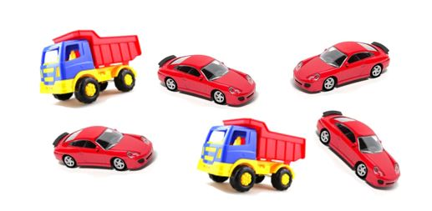  4:2 or 2:1 if they simplify  This cannot be written in fraction form as it is part:part not part:all  “4 to 2” would be acceptable but have a conversation about ratio notation
N 7.6 Integers | N6.8 Ratios
41) Solve for n.  $$\text{n}\text{ + 6= 14}$$  n = 8 | 42) Solve for x:  $7x=35$ x=5
P5.2 P6.2 Equations | P6.2Equations
43) Solve for t:  $3t+5=23$ t = 6 | 44) Solve for x:  $\frac{x}{4}=7$ x = 28
P 7.3 Two Step Equation | P 7.3 Equation
45) Solve for x:  $$\frac{x}{5}-3=7$$  x = 50 | 46) Evaluate the expression  $2x-5$ when $x=3$  2(3) – 5 = 1
P 7.3 Two Step Equation | P 7.2 Evaluate Expression
47) Write the rule with words or an equation y=4x-1
x y
1 | 3
2 | 7
3 | 11
4 | 15
5 | 19

P6.1, P7.1 Tables and Graphs
Figure number | Number of Blocks
1 | 2
2 | 5
3 | 8
4 | 11
5 | 14
48) Create a table of values for this increasing pattern
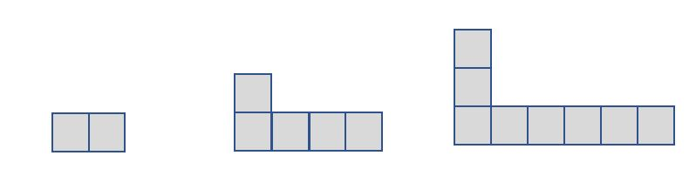
Fig. 1 Fig.2 Fig. 3

P6.1 Table from pattern
Input | Output
1 | 1
2 | 3
3 | 5
4 | 7
5 | 9
49) Create an input/output table from this graph

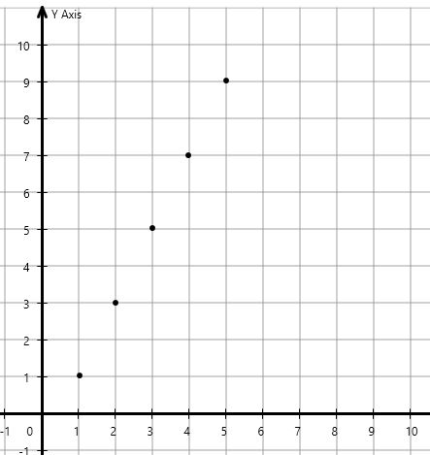
P6.1, P7.1 Tables and Graphs
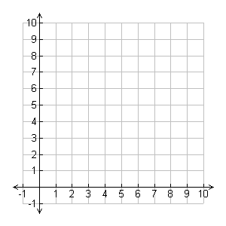
50) Graph using the table of values
x | y
0 | 1
3 | 4
4 | 5
7 | 8

P6.1, P7.1 Tables and Graphs
51) Write an equation to represent the rule for this table. Use C for cost and n for number of guests.  Number of Guests Cost  1 20  2 40  3 60  5 100  n | 52) Fill in the table for  $$y=3x+2$$  x y  1 5  2 8  3 11  4 14
P6.3 Write an equation from a table | P 7.1 Create table from equation
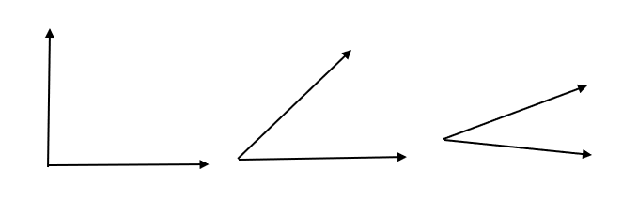
53)Circle the angle that is about 45

SS6.1 Angles
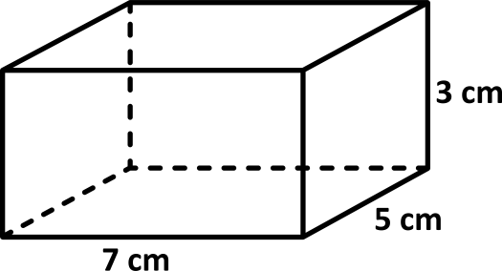
54) Find the volume 105 cm³

SS 6.2 Volume
55) The diameter of this circle is 12cm. What is the measure of it’s radius?  r  D=12cm  r=_6 cm____ | 56) Find the area of this triangle  $A=bh/2$ or $A=1/2 bh$ 24cm²  6 m  For these area questions, if the student knows how to do the work but forgets units or exponents on units, have a conversation and/or allow them to add their units in, but you can mark the item correct.  8 m
SS7.1 Diameter and radius | SS7.2 Area of triangle
57) How many minutes of homework did Ms. Smith give on Thursday?
16 minutes
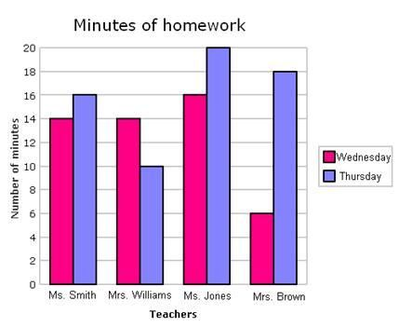
SP5.2 Double Bar Graph
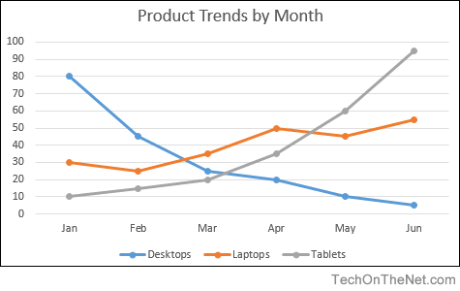
58) About how many laptops were sold in April? 50 Laptops
SP 6.1 Line graphs and data
59) There are six marbles in this bag. If you reach into the bag and pull out one marble, what is the probability you pull out a white one? $\frac{1}{6}$

SP 7.3 Probability

