Christ the Teacher Grade 8 Screener H1 Name__________________
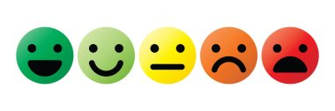
How do you feel about Math? Circle one

1) Write the value of the underlined digit.  62 421 384 | 2) Write the value of the underlined digit:  4.268451
N6.1 Place value | N 7.2 Place value/decimal
3) Circle all the numbers divisible by 3  135 65 355 54 9 | 4) All these numbers are divisible by what number?  15 45 90 10 125
N 7.1 Divisibility rules | N 7.1 Divisibility rules
5) Write the number 345 605 084 in expanded form.
N 6.1 Representing Number
6) Write the number 2.3 billion in standard form | 7) What is the greatest common factor of 48, 16 and 40?
N 6.1 Representing Number | N6.2 Factors and Multiples
8) What is the least common multiple of 3,4, and 6? | 9) Circle all the prime numbers  10 15 17 5 21 29 11
N6.2 Factors and Multiples | N6.2 Factors and Multiples
10) Use any method you like to write all the prime factors of 36 | 11) Calculate  $$10÷2+3×(9-2)=$$
N6.2 Factors and Multiples | N 6.3 Order of Operations
12) Calculate  $12-0.5×1.2=$ | 13) Express as an improper fraction  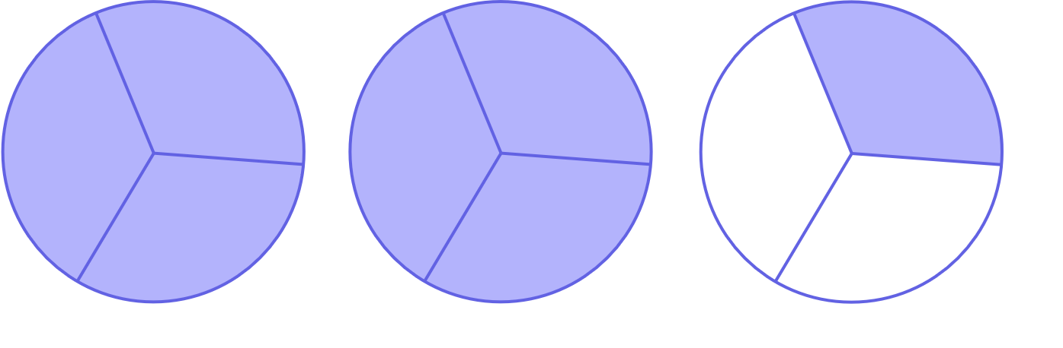
N 7.2 Order of Operations, decimals | N6.7 Fractions
14) Change to a mixed number | 15) Write as an improper fraction (common fraction)
N6.7 Fractions | N6.7 Fractions
16) Write in lowest terms (reduce/simplify)  $$\frac{12}{18}$$ | 17)  4.5 + 0.73 + 256.458=
N7.5 Fractions | N 7.2 Add Decimals
18)  6 – 3.682= | 19) Place the decimal where it belongs in this product  $$16.324 ×3.15=514206$$
N 7.2 Subtract Decimals | N 6.4Mult and Div of decimals
20) Place the decimal where it belongs in this quotient

$$42.539 ÷5.15= 826$$
N 6.4Mult and Div of decimals
21) Find the product  0.891  ×16 | 22) Divide (do not leave a remainder)  24.025 ÷ 5 =
N 6.4, N 7.2 Mult and Div of decimals | N 6.4, N7.2 Mult and Div of decimals
23) Shade 18% of this hundredths grid  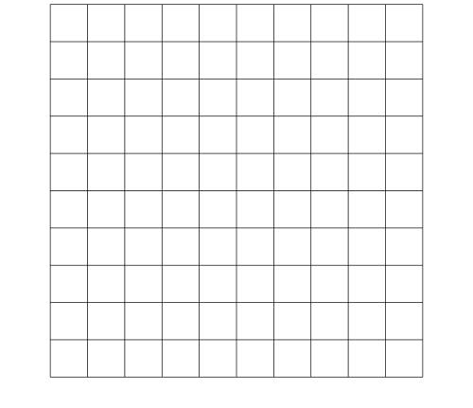 | 24) What percent of this shape is shaded?  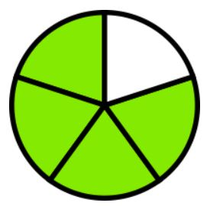
N 6.5 Percent | N 6.5, N7.4 Percent and Fraction
25) Express 35% as a fraction | 26) Write $3/100$ as a decimal.
N 6.5, N7.4 Percent and fraction | N 7.4 Fraction and Decimal
27) Write 0.72 as a percent  0.72 = ______% | 28) Write 0.04 as a percent  0.04 = ______%
N 7.4 Decimal and Percent | N 7.4 Decimal and Percent
29) Write 0.145 as a percent  0.145 = ______% | 30) Order the following from least to greatest  0.56 3 1.4 1.389  ________ _____ _____ _______ _____ _____ _____
N 7.4 Decimal and Percent | N 7.3 Fraction and Decimal
31) Order the following from least to greatest

$3/5$ $5/8$ $1 2/3$ $5/4$ $1$

_____ _____ _____ _____ _____

N 7.3 Fraction and Decimal
32) Place the following approximately where they belong on the number line

$1/3$ 0.25 $9/10$ 1.2 $3/5$

$$\frac{1}{2}$$
1
0

N 7.3 Fraction and Decimal
33) Add  $$6 \frac{2}{3}+1 \frac{5}{6}=$$ | 34) Subtract  $$4-1 \frac{1}{5}=$$
N7.5 Fraction | N7.5 Fraction
35) Insert either < , >, or = between these two integers

-6 -10
N6.6 Integers
36) Place these integers on the number line

+5 -5 +2 0 -4 +4

N6.6 Integers
37)  $$(+8)+(-10)=$$ | 38)  $$(-12)-(+6)=$$
N 7.6 Integers | N 7.6 Integers
39)  $$(-17)-(-20)=$$ | 40) What is the ratio of cars to trucks?  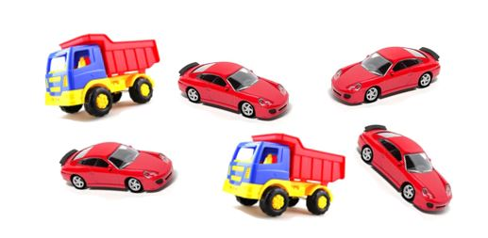
N 7.6 Integers | N6.8 Ratios
41) Solve for n.  $$\text{n}\text{ + 6= 14}$$ | 42) Solve for x:  $$7x=35$$
P5.2 P6.2 Equations | P6.2Equations
43) Solve for t:  $$3t+5=23$$ | 44) Solve for x:  $$\frac{x}{4}=7$$
P 7.3 Two Step Equation | P 7.3 Equation
45) Solve for x:  $$\frac{x}{5}-3=7$$ | 46) Evaluate the expression  $2x-5$ when $x=3$
P 7.3 Two Step Equation | P 7.2 Evaluate Expression
47) Write the rule with words or an equation

1 | 3
2 | 7
3 | 11
4 | 15
5 | 19

P6.1, P7.1 Tables and Graphs
Figure number | Number of Blocks
48) Create a table of values for this increasing pattern
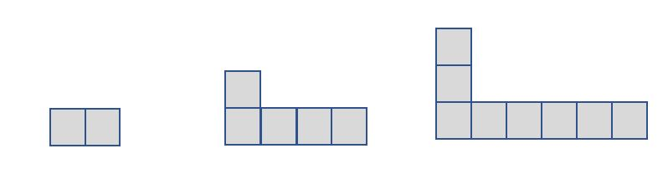
Fig. 1 Fig.2 Fig. 3

P6.1 Table from pattern
Input | Output
49) Create an input/output table from this graph

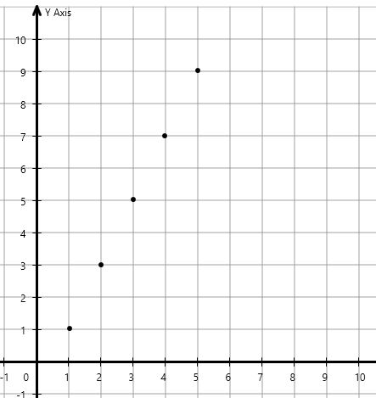
P6.1, P7.1 Tables and Graphs
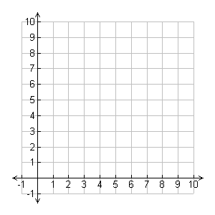
50) Graph using the table of values
x | y
0 | 1
3 | 4
4 | 5
7 | 8

P6.1, P7.1 Tables and Graphs
51) Write an equation to represent the rule for this table. Use C for cost and n for number of guests.  Number of Guests Cost  1 20  2 40  3 60  5 100  n | 52) Fill in the table for  $$y=3x+2$$  x y  1  2  3  4
P6.3 Write an equation from a table | P 7.1 Create table from equation
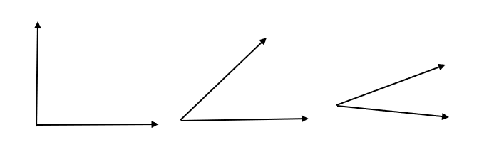
53)Circle the angle that is about 45

SS6.1 Angles
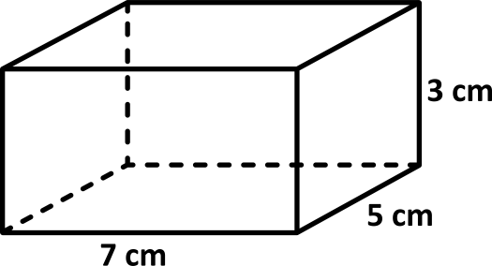
54) Find the volume
SS 6.2 Volume
55) The diameter of this circle is 12cm. What is the measure of it’s radius?  r  D=12cm  r=_____ | 56) Find the area of this triangle  $A=bh/2$ or $A=1/2 bh$  6 m  8 m
SS7.1 Diameter and radius | SS7.2 Area of triangle
57) How many minutes of homework did Ms. Smith give on Thursday?

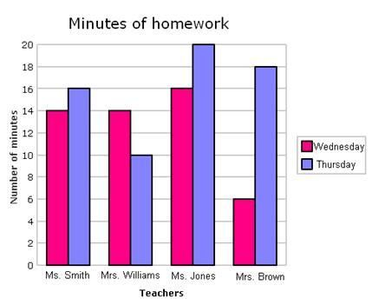
SP5.2 Double Bar Graph
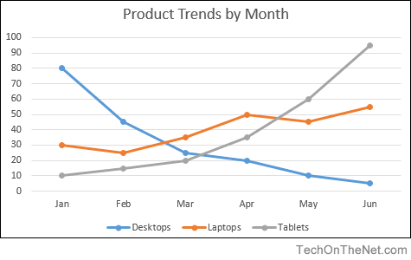
58) About how many laptops were sold in April?
SP 6.1 Line graphs and data
59) There are six marbles in this bag. If you reach into the bag and pull out one marble, what is the probability you pull out a white one?

SP 7.3 Probability

