Christ the Teacher Grade 9 Screener I1 Name__________________
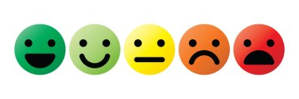
How do you feel about Math? Circle one

1) Write the value of the underlined digit:  4.268451 | 32 Circle all the numbers divisible by 3  135 65 355 54 9
N 7.2 Place value/decimal | N 7.1 Divisibility rules
3) All these numbers are divisible by what number?  15 45 90 10 125 | 4) What is the greatest common factor of 48, 16 and 40?
N 7.1 Divisibility rules | N6.2 Factors and Multiples
5) Use any method you like to write all the prime factors of 36 | 6) What is the least common multiple of 3,4, and 6?
N6.2 Factors and Multiples | N6.2 Factors and Multiples
7) Circle all the prime numbers  10 15 17 5 21 29 11 | 8)  $\sqrt{121}$ =
N6.2 Factors and Multiples | N8.1 Square root
9)  ${ 8}^{2}$= |  | 10) Calculate  $$10÷2+3×(9-2)=$$
N 8.1 Square a number |  | N 6.3 Order of Operations
11) Show approximately where $\sqrt{75}$ would go on the number line

N8.1 Approximate Square root
12) Write in lowest terms (reduce/simplify)  $$\frac{12}{18}$$ | 13) Express as an improper fraction  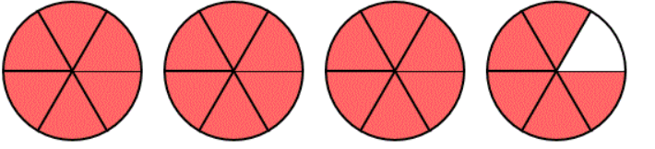
N7.5 Fractions | N 6.7 N7.5 Fractions
14) Express as a mixed number  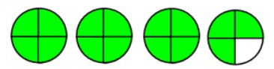 | 15) Express as a mixed number  $$\frac{14}{3}$$
N 6.7 N7.5 Fractions | N7.5 Fractions
16) Calculate  4.5 + 0.73 + 256.458= | 17) Calculate  $12-0.5×1.2=$
N 7.2 Add Decimals | N 7.2 Order of Operations, decimals
18)  6.5 – 3.682= | 19) Place the decimal where it belongs in this product  $$16.324 ×3.15=514206$$
N 7.2 Subtract Decimals | N 6.4Mult and Div of decimals
20) Place the decimal where it belongs in this quotient

$$42.539 ÷5.15= 826$$
N 6.4Mult and Div of decimals
21) Find the product  0.891  ×16 | 22) Divide (do not leave a remainder)  24.125 ÷ 5 =
N 6.4, N 7.2 Mult and Div of decimals | N 6.4, N7.2 Mult and Div of decimals
23) What percent of this shape is shaded?  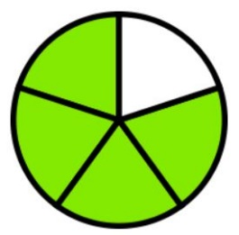 | 24) What percent is shown here?  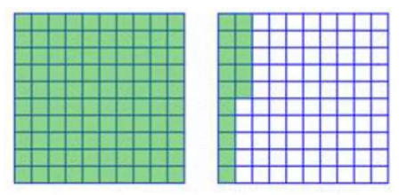
N 6.5, N7.4 Percent and Fraction | N 8.2 Percent greater than 100
25) Express 35% as a fraction | 26) Write $3/100$ as a decimal.
N 6.5, N7.4 Percent and fraction | N 7.4 Fraction and Decimal
27) Write 0.72 as a percent  0.72 = ______% | 28) Write 4% as a decimal  4% = ______
N 7.4 Decimal and Percent | N 7.4 Decimal and Percent
29) Write 0.145 as a percent  0.145 = ______% | 30) Find 10% of 280
N 8.2 Percent less than 1 | N 8.2 Decimal and Percent

31) Find 120% of 30 |  | 32) Calculate  $$32 358.4÷1000=$$
N 8.2 Decimal and percent |  | N 8.2 Decimal and percent
33)Write $3/4$ as a percent. | 34) Order the following from least to greatest  $\frac{3}{5}$ $\frac{5}{8}$ $1\frac{2}{3}$ $\frac{5}{4}$ $1$ _____ _____ _____ _____ _____
N 8.2 Decimal and Percent | N 7.3 Fraction and Decimal
35) Place the following approximately where they belong on the number line

$1/3$ 0.25 $9/10$ 1.2 $3/5$

$$\frac{1}{2}$$
1
0

N 7.3 Fraction and Decimal
36) Add  $$6 \frac{2}{3}+1 \frac{5}{6}=$$ |  |  |  | 37) Subtract  $$4-1 \frac{1}{5}=$$
N7.5 Fraction |  |  |  | N7.5 Fraction
38)  $\frac{3}{8}×\frac{4}{15}=$ |  |  | 39)  $$\frac{5}{8}÷\frac{3}{4}=$$
N 8.4 Multiply Fraction |  |  | N 8.4 Divide Fraction
40)  $$\frac{4}{5}×20=$$ |  |  | 41)  $6÷\frac{2}{3}=$
N 8.4 Multiply Fraction |  |  | N 8.4 Divide Fraction
42) Calculate using order of operations

$$\frac{3}{4}+\frac{1}{3}×\frac{5}{8}=$$
N 8.4 Order of Operations with Fractions
43)  $$(+8)+(-10)=$$ |  |  |  | 44)  $$(-12)-(+6)=$$
N 7.6 Add Integers |  |  |  | N 7.6 Subtract Integers
45)  $$24÷\left(-6\right)=$$ |  |  |  | 46)  $$\left(-8\right)×\left(-6\right)=$$
N 8.5 Divide Integers |  |  |  | N 8.5 Multiply Integers
47)  $$(-17)-(-20)=$$ |  |  |  | 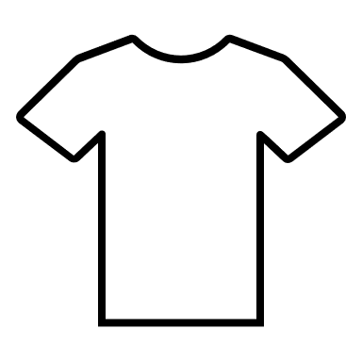  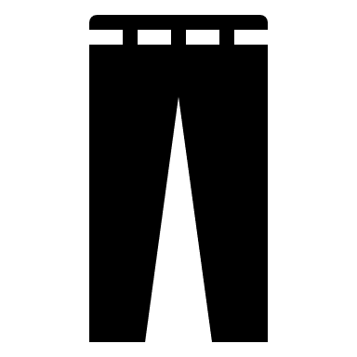  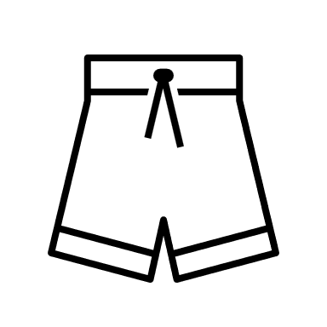  48) Write a ratio to express the number of shirts to all clothing items.
N 7.6 Integers |  |  |  | N8.3 Ratios
49) To make hot chocolate, you need 5 scoops of powdered mix for every 2 cups of hot water. How many scoops of powder should you use in a thermos that holds 8 cups? |  |  |  | 50) Solve for t:  $$3t+5=23$$
N 8.3 Proportional Reasoning, rates |  |  |  | P 7.3 Two Step Equation
51) Solve for x:  $$\frac{x}{4}=7$$ |  |  |  | 52) Solve for x:  $$\frac{x}{5}-3=7$$
P 7.3 P 8.2 Equation |  |  |  | P 7.3 P 8.2 Two Step Equation
53)  $$3\left(x+5\right)=36$$ |  |  |  | 54) Evaluate the expression  $2x-5$ when $x=8$
P 8.2 Solve equation with brackets |  |  |  | P 7.2 Evaluate Expression
55) Write the rule with words or an equation

x | y
1 | 3
2 | 7
3 | 11
4 | 15
5 | 19

P6.1, P7.1 Tables and Graphs
Input | Output
56) Create an input/output table from this graph

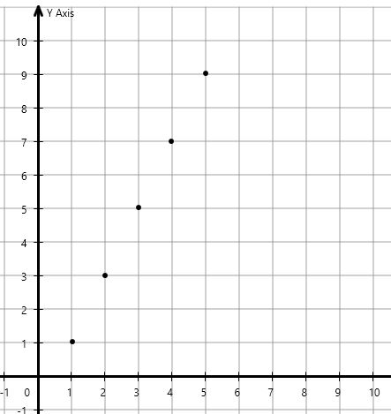
P6.1, P7.1 Tables and Graphs
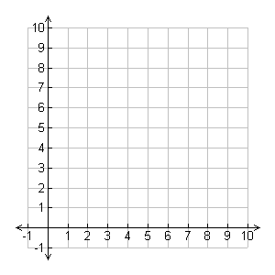
57) Graph the line using the table of values
x | y
0 | 1
3 | 4
4 | 5
7 | 8

P6.1, P7.1 Tables and Graphs. SS7.4 points and the Cartesian plane
58) Fill in the table and draw the graph of the line.
$$y=3x+2$$
x | y
0
1
2
3

P 8.1 Create graph from equation
59) Circle the point that lies on the line $y=-2x+5.$

$(3,-1)$ or $(5,2)$
P 8.1 Points on line
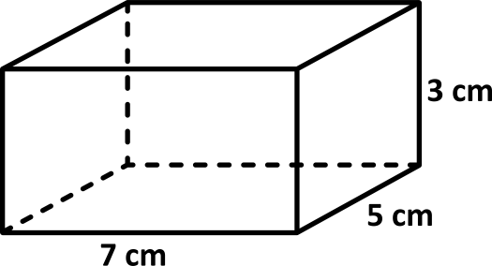
60) Find the volume.
SS 6.2 Volume
61) The diameter of this circle is 12cm. What is the measure of it’s radius?  r  D=12cm  r=_____ |  |  |  | 62) Find the area of this triangle  $A=bh/2$ or $A=1/2 bh$  6 m  8 m
SS7.1 Diameter and radius |  |  |  | SS7.2 Area of triangle
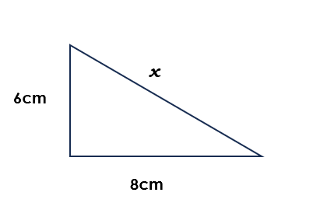
63) Solve for x

SS8.1 Pythagorean Theorem
64) Calculate the surface area of this prism
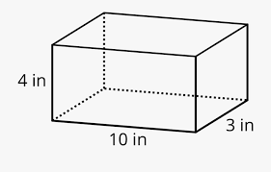
SS8.2 Surface Area
65) There are six marbles in this bag. If you reach into the bag and pull out one marble, what is the probability you pull out a white one?

SP 7.3 Probability
66) Explain what this data shows about moose and wolf populations in Saskatchewan.
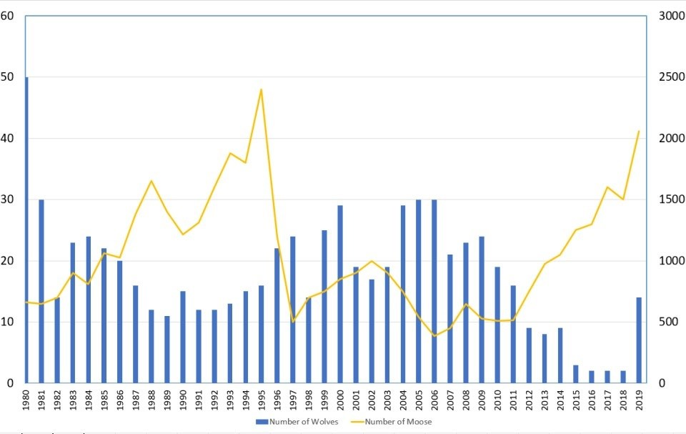

Moose
Wolves
SP 8.1 Interpreting data

