Summary of strategies from “Communicating in Mathematics”-Sept 28

- Taking regular practice and making it more collaborative
- Making debates instead of doing independent practice problems—Here’s an example using multiple choice questions from text. They are simply copied to cards and students are asked to collaboratively solve.
https://drive.google.com/file/d/1gX71o8el6YsZkaMMhloCX1diFTJU9d-K/view?usp=sharing

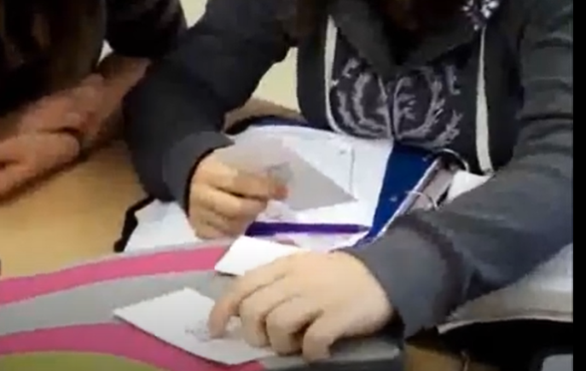

- Practicing a new skill from examples on the board? After students have tried your practice questions, put them on the board. Write student initials by each question. Choose 2 students that are not in close proximity. Rule is they have to confer with each other and agree on an answer, then one or both students contributes their solution (with work shown!) on the board.

- Flip the assignment to make it more collaborative and require deeper thinking:
For example, instead of Draw a graph of this situation, present a graph and have groups of students write the “story” that goes with the graph. Groups take turns presenting their graph under document camera and explaining the situation they came up with .
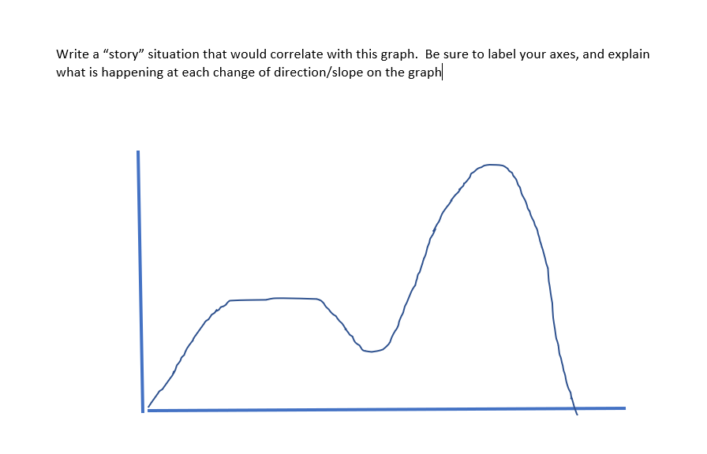
For example, I’ve had this graph explained as your ice cream craving over time in the summer, your hair length over time, the money in your bank account, snowfall, and once even how many boyfriends you’ve had (which made for great discussion since obviously the person in the graph is dating many guys at once! Haha! Maybe the max point of the graph is where all these guys find out they’re dating the same girl and they all dump her).
Many times groups have talked about this as a mountain climber, or mountain biker, which tells me they don’t understand the idea of relationships in a graph. This is formative assessment evidence you would never get from kids just doing the assignment.

There are lots of text book assignment questions that can be flipped in this way.

- Formative assessment ideas that generate math talk
- Commit and toss http://web.wnlsd.ca/enrichment/FormativeassessmentResources/Commit_and_Toss.pdf
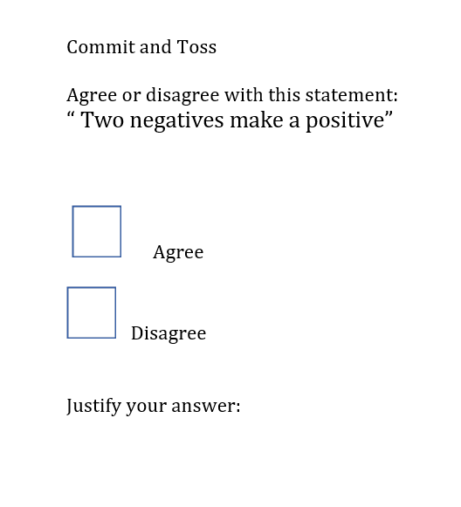
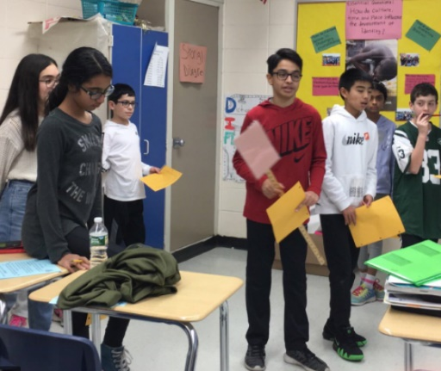
- Four corners: “In this strategy, students individually choose a response to a question or prompt and move to an area in the room where they join others who share their ideas and responses. This strategy is flexible and can be used for many topics, questions, and problems in mathematics.” https://oame.on.ca/main/files/thinklit/FourCorners2.pdf

- Gallery Walk https://www.sfusdmath.org/gallery-walk.html
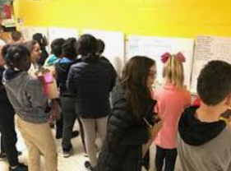

When time is short you can modify this activity to “group hosting” where instead of everyone seeing every group’s posted work, pairs of groups “host” each other over at their posters and explain their reasoning.

- Card matching. Need to create partners for a day? Meet kids at the door, and everyone gets a card (or a quickly cut up hand drawn piece of paper, whatever!)
You can have graphs to match with equations, graphs to match with slope, slope to match with equation, equations in 2 different forms, polynomials simplified and expanded, fractions as mixed and improper, fractions as models and as numbers, numbers as fraction or decimal, or fraction/decimal/percent for a group of 3, any equation with the solution, etc…so that kids find their partner. They need to be able to justify why that person is their partner (why their cards match)
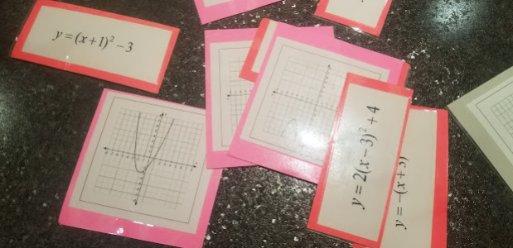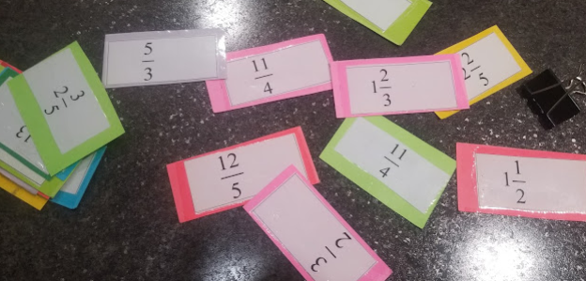

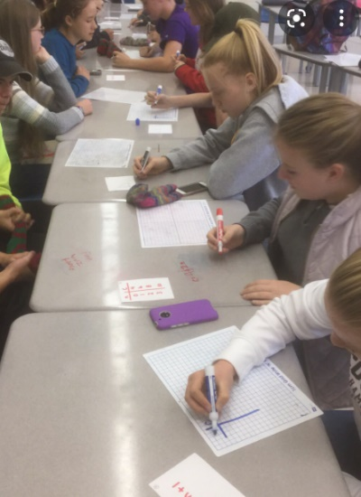
- Peer coaching ideas
- Math Speed dating
https://ispeakmath.org/tag/speed-dating/

Each student is an “expert” at one problem. Works well for multistep problems, solving equations, order of operations, etc. With each new partner the student guides their partner through solving their problem, then the two switch roles (student vs coach) and solve the other person’s problem. When everyone is done one side of the long table all move down a seat. Now each person has a new problem or equation to solve, but they still coach their new partner on their own equation, which they got to be an expert at.

- Rally Coach (from Cooperative Learning, Dina Kushner
Student A completes a problem while doing a “think aloud”—telling what they’re doing. The partner B listens, and coaches. If A gets stuck, B is only allowed to ask prompting questions. Then roles reverse.

- Scripted peer coaching—is like Rally Coach but the “coach” (B) has a worked solution to the problem to guide them. Only the coach can see the work and answer. They can ask prompting questions to A who is solving the problem.

There are many more communication strategies that work well! Row problems, Graffiti activities, inside-outside circle, hot-seat questioning, and others. Have fun exploring these!

Could you explain that to me another way?

What I heard you say is……

I know my answer is correct because….

Something that I will need to remember here is…..

Another strategy I could use to verify the results is….
The part I don’t understand well is…..

I have a question about…
I agree with the results because

I’m still a little fuzzy about…..

Another way I can prove my results is….

A helpful tip here is……

Can you tell me more about……

I noticed that you….
The method/ approach I used is…..
Can you tell me why you think that?

Something that helped me understand this
is….

