St. Theodore School
Where the knowledge of God is the foundation of learning
Box 430 Theodore SK. S0A 4C0 Phone: 647-2762 Fax: 647-2024
tammy.morrison@cttcs.ca www.sttheodore.christtheteacher.ca
Christ the Teacher Roman Catholic School Division #212
December Newsletter
Dates to Remember
Dear St. Theodore Families,
It is hard to believe that it is already December! Things are still not what we had hoped and prayed they would be this Advent and Christmas season. We still have much to be grateful for and we must support each other and try to not only find our light but be the light for others. Christ is our light and if we lean on Him, He will always lead us where HE needs us to be. As we prepare our homes and tables to celebrate this season, let us not forget to prepare our hearts for the Birth of Jesus, the greatest gift ever.
Advent is a time to wait, not quite time to celebrate.
Light the candles one by one, 'til this Advent time is done.
Christmas Day will soon be here, time for joy and time for cheer.

This season make some time to prepare
-Make a family Advent Wreath – Light a candle each week or every night at dinner time and include a short prayer.
-Christmas Tree Blessing – Before you decorate the tree or on a special evening after the tree is decorated, take some time to pray together as a family.
-Advent Devotionals –Take time to reflect on the prayers and celebrations offered in our parishes.
-Nativity Scene – Display the scene with a wrapped or hidden Jesus to help family grow in the longing for Him and unveil the Christ Child on Christmas morning.
Wishing everyone a Blessed and Merry Christmas!
Mrs. T. Morrison on behalf of all the St. Theodore Staff

Cuddle Up and Read
Advent is a time to share. Once again, our Advent project encourages our families and community members to purchase new pajamas of all sizes, a new book, and/or cash donation. What a great present it would be to have a warm, new pair of pajamas and read a storybook before bedtime, especially at Christmas!
We will hold our Pajama Drive from December 1st until Thursday, December 16th. We will then pass these special packages to families who are staying at the Shelwin House in Yorkton.

Parish Information
St. Gerard’s Roman Catholic Church,
Yorkton
Email-office@st.gerard.ca
Saturday Mass: 5pm
Sunday Mass: 9 am and 11:00
Due to COVID restrictions please
contact the church for information

St. Mary’s Ukrainian Catholic Church, Yorkton
Email- st.mary.yorkton@sasktel.net
Saturday Divine Liturgy: 5pm (English)
Sunday Divine Liturgy: 9 am (Ukrainian) 11 am (English)
Due to COVID restrictions, please contact the parish office for mass guidelines.

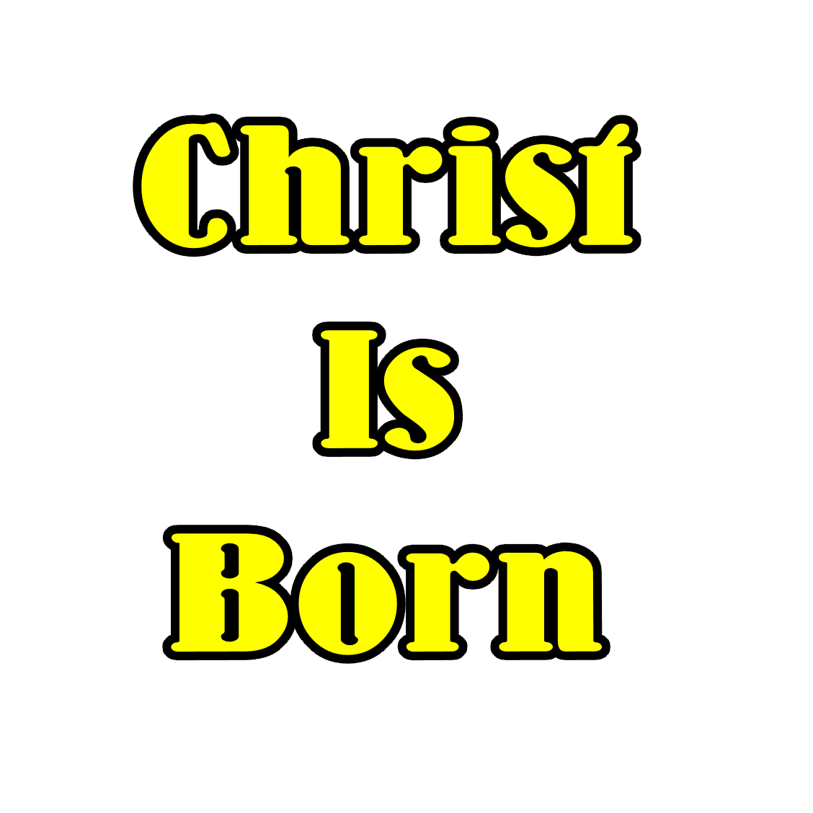

Sun. Nov 28 | 1st week of Advent – Theme of HOPE
Wed. Dec. 1 | Christmas Plant fundraiser pickup  12:00pm-6:00pm use GYM door for pickup
Fri. Dec 3 | SHHS presents MADAGASCAR streamed to our students.
 | Skills Canada & Chatterhigh presentation Gr 4-8
Sunday, Dec. 5 | 2nd week of Advent – Theme of FAITH
Sunday, Dec.12 | 3rd week of Advent – Theme of JOY
Mon. Dec. 13-Fri. Dec. 17 | Christmas Spirit Week (details to follow)
Fri. Dec 17 | 4th week of Advent celebration
Sun. Dec. 19 | 4th week of Advent – Theme of PEACE
Dec. 20– Jan. 3 | Christmas Holidays
Mon. Jan. 4 | Classes resume - Day 2
Mon. Jan 31 | No School – Teacher Inservice
Tues. Feb. 1 | No School – Teacher Inservice
Mon. Feb 14 | St. Valentine’s Day
Mon Feb. 21 | Family Day- No school
Feb.22 – Feb.24 | Mid-Winter Break – No School
Mon. Feb.28 | Classes Resume- Day 4

Many Thanks
- We thank everyone for supporting our Christmas fundraiser The plants will be ready for pick up Wednesday, Dec. 1 from12:30-6:00 pm at the gym doors. Please do not use the main doors.
- our great families that came to share in the success and celebration of learning with your child during student-led conferences.
COVID GUIDELINES:
All students and visitors are required to wear masks in school. All visitors are still asked to sign in at the school.
After Dec 6/21 CTTCS division policy states that any visitors to the school who will be in direct contact with staff or students for longer than 15 minutes will be asked to provide proof of vaccination or a negative Covid test. Only essential, scheduled visitors are encouraged at this time. Thank you for your continued support.

Christmas Program:
Due to the ongoing COVID restrictions and implementation of current guidelines, St. Theodore will once again provide our families with a virtual Christmas Program.
Our wishes for the season remain the same, the presentation is just a bit different! Link will be sent out before Christmas break.

